NMR Drylab Exercises: Non-first-order NMR

Aims
Provide practice in recognising and analysing AB spectra and sub-spectra
Introduce sub-spectral analysis
Introduce signs of coupling constants
Present equations and formulae for solving AB, ABX, AB₂ and AA′XX′ systems
Give confidence in carrying out the arithmetic manipulations required to solve these systems

Objectives
At the end of this exercise you should be able to:
- obtain the coupling and chemical shifts from an AB spectrum;
- find AB sub-spectra in an ABX system;
- solve the equations necessary to find all couplings and shifts for the AB part of this;
- recognise, and find the coupling and chemical shifts for, an AB₂ system;
- find AB₂ sub-spectra in an AB₂X satellite spectrum and hence find couplings and shifts, including a secondary isotope shift;
- find AB sub-spectra in an AA′MM′ system and hence find couplings and shifts

Introduction
If we have one atom each of two different nuclear species with I = ½, e.g. ³¹P and ¹H or ⁷⁷Se, coupled in a molecule, then we have an AX spin system. Each of the two spectra consists of a 1:1 doublet. Call the chemical shifts measured in Hz ν_{A} and ν_{X}, and the coupling between them J_{AX}. As the nuclear spin quantum number I of nucleus X is ½, its resolved spin quantum number m_{I}, which runs in steps of 1 between +I and −I (like m_{l} between +l and −l, or m_{s} between +s and −s for an electron), can have values −½ or +½. As shorthand, we will write m_{X} = −½ or m_{X} = +½. This means the magnetic field of nucleus X can be aligned opposite to the magnetic field of the NMR machine (most stable, subtracts from the applied field) or aligned with it (least stable, adds to the applied field). Nucleus A then absorbs at two possible frequencies, or ‘effective chemical shifts’, ν_{A}⁻ and ν_{A}⁺ (in general ν_{A}*) depending on whether it feels the magnetic field of nucleus X subtracted from or added to the applied field. The strength of the interaction between A and X is the coupling constant J_{AX}, and the effective shifts of A (in this case the positions of the peaks of the A doublet) are given by
ν_{A}* = ν_{A} + m_{X}J_{AX} (1)
which comes out to
ν_{A}⁺ = ν_{A} + ½J_{AX} (2)
ν_{A}⁻ = ν_{A} − ½J_{AX} (3)
There is a theoretical complication: nucleus A may not feel the magnetic field of X in the same sense as if it were through empty space. The coupling constant normally is transmitted by electrons, which is why knowing about it tells us something about the electronic structure of the molecule; in many cases the effective chemical shift of A is moved in the opposite direction from that expected for a direct interaction. In other words, J_{AX} can be positive or negative, and the high frequency line of the A doublet can correspond to ν⁺ or to ν⁻. As the two lines of an AX doublet are equal, we cannot tell from a simple NMR experiment which is which. Therefore we cannot find the sign of J_{AX} directly for an AX system. Later in this exercise you will meet more complex spectra which are not symmetrical, where the relative sign of J is obtainable, and where we will need to sort out which is ν⁺ and which is ν⁻.
For our AX system, to find the chemical shift ν_{A} and the coupling J_{AX}, you solve the pair of simultaneous equations (2) and (3). This is extremely simple! To get ν_{A}, you add the two equations together and divide by two: J_{AX} cancels out. This is the same as saying that to get the chemical shift of A you average the frequencies of the two lines of its doublet. To get J_{AX}, you subtract equation (3) from equation (2), so ν_{A} cancels out. This is the same as saying that to find the coupling you subtract the frequency of one line of the A doublet from that of the other. The splitting of the doublet is the same as the coupling for an AX system. You knew all that already! It is necessary to set out the equations in this way because you are going to use the same methods for more complex systems, where the answer is not trivial. Solving these equations involves only adding and subtracting and possibly dividing by two, which are all first order arithmetic operations. Therefore an AX spin system is called a ‘first order system’.

Problem 1
At an operating frequency of 121.499 MHz, the ³¹P{1H} spectrum of Ph₃PSe shows a satellite spectrum of two equal peaks at 4795.997 and 4035.354 Hz, caused by coupling to ⁷⁷Se (i.e. an AX system). (There is also a much larger peak at 4415.673 Hz, the main ³¹P spectrum, due to molecules which contain any of the other isotopes of selenium which do not have I = ½ and therefore do not show coupling to phosphorus.) Calculate the coupling constant ¹J(³¹P⁷⁷Se) to one decimal place, the chemical shift in Hz of phosphorus in molecules containing ⁷⁷Se, and this shift in ppm, to two decimal places.

1(a) ¹J(³¹P⁷⁷Se) = Hz

1(b) ν_{P}(⁷⁷Se) = Hz

1(c) ν_{P}(⁷⁷Se) = ppm

If the difference in chemical shifts of A and X is called δ_{AX}, i.e.
δ_{AX} = ν_{A} − ν_{X} (4)
then first order systems are found only when J_{AX}/δ_{AX} is practically zero. If there is a non-zero coupling, this means that δ_{AX} is practically infinity. This is true when A and X are two different nuclear species, e.g. ³¹P and ¹H (or ³¹P and ⁷⁷Se as above), which have their absolute absorption frequencies megahertz apart. If the two nuclei are both of the same species, e.g. both ³¹P or both ¹H, then δ_{AX} is not infinity and the spectrum is not first order. We should call the spin system AM, AF or even AB. However, if J/δ is small, it is convenient to use the simple first order arithmetic and suffer a little error. We say we are ‘making the X approximation’. Organic chemists commonly say that this is justified if J/δ≤0.1, but a more realistic limit is 0.05. We shall see now how to tackle systems with bigger J/δ.

The AB system
In the first order AX system, the molecule can be thought to be in two different separate states, depending on the value of m_{X}: we can analyse the spectrum of A as the superposition of two different sub-spectra, + and −, for the two values +½ or −½ of m_{X}. We say that m_{X} is a ‘good quantum number’, because it can vary independently of the other quantum numbers. In an AB system, this is not so: if we wanted to analyse the effect of the AB pair on another nucleus X, we would have to take a combined quantum number for A and B together. This is beyond the scope of this exercise, and in a normal laboratory situation one does not start there: a computer program can predict the appearance of the X spectrum once you have the couplings from elsewhere. It is much easier to analyse the AB part, since an AB spectrum (or sub-spectrum for a particular value of a good quantum number m_{X}) always looks the same in principle, and can be analysed by some simple rules. We will do this next.

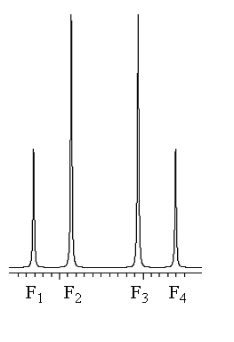
An AB system consists of four lines. Call the frequencies of these F₁...F₄, as in the diagram.
There are two equal splittings, equal to the coupling constant:
|J_{AB}| = F₁−F₂ = F₃−F₄ (5)
This is the same as for an AX spin system: if you take the X-approximation for an AB system, you still get the correct coupling constant. You still cannot find the sign of J. The AB spectrum has reflection symmetry, i.e. the tenting on one side is the same (reflected) as the tenting on the other. If the intensities are I₁...I₄ then
I₂/I₁ = I₃/I₄ = (F₁−F₄)/(F₂−F₃) (6)
You can use equation (6) to test whether you have found the two halves of the same AB spectrum, if several overlap. (In the X limit, when J_{AX} is negligible compared with δ_{AX}, the outside separation F₁−F₄ is essentially equal to the inside separation F₂−F₃, so equation (6) evaluates to one, i.e. the peaks are all the same height.)
Besides the tenting, the essential difference between an AX and an AB spectrum is the calculation of the chemical shifts. The midpoint of the AB spectrum is the average of ν_{A} and ν_{B} (as in the AX case):
midpoint_{AB} = (ν_{A}+ν_{B})/2 = (F₁ + F₄)/2 = (F₂ + F₃)/2 (7)
but the difference between ν_{A} and ν_{B} is given by:
δ_{AB} = ν_{A} − ν_{B} = √((F1−F4)(F2−F3)) (8)
This involves multiplying and taking a square root, so this is second order arithmetic. In general, we call a system which is not first order, ‘non-first-order’. To find the chemical shifts ν_{A} and ν_{B}, we use equation (7) to find the midpoint and equation (8) to find δ. Then
ν_{A} = midpoint_{AB} + δ_{AB}/2 (9)
ν_{B} = midpoint_{AB} − δ_{AB}/2 (10)

Problem 2
The four lines of the ³¹P AB spectrum shown above are at
18906.223, 18679.424, 18280.477, 18053.680 Hz.
Calculate ν_{A}, ν_{B} and J_{AB} in Hz, all to one decimal place. (Hint: if you have free storage locations available, store all four frequencies in your calculator before you start.)

2(a) midpoint_{AB} = Hz

2(b) δ_{AB} = Hz

2(c) ν_{A} = Hz

2(d) ν_{B} = Hz

2(e) J_{AB} = Hz

(The data are for PCl₂PClBr. It is known that ¹J couplings between three-coordinate phosphorus atoms are negative, so here J_{AB} is negative, but you cannot find this out directly for a simple AB spectrum. The higher chemical shift belongs probably to the PCl₂ group, and the lower to the PClBr group, by comparison with the chemical shifts of P₂Cl₄ and P₂Br₄ respectively. This is supported by peak widths: the higher frequency two peaks in the experimental spectrum were noticeably broader than the lower frequency two, because coupling to either isotope of chlorine is less completely obliterated by quadrupolar relaxation than in the case of either isotope of bromine.)

The ABX system
AB spectra most often come as sub-spectra in which A and B are each coupled to another nucleus X.

Problem 3

For an example where X really is a different nuclear species, consider P₂Se₅. The molecule has C_{2v} symmetry, so P_{A} and P_{B} are chemically equivalent, and the main phosphorus spectrum is a singlet, corresponding to molecules which do not contain any ⁷⁷Se. However, there is a 23% chance that one of the four chemically equivalent selenium positions will contain ⁷⁷Se, as shown in the displayed formula. Se_{X} will couple differently to P_{A} than it does to P_{B}, making P_{A} and P_{B} magnetically non-equivalent, even though they are essentially chemically equivalent. This is then an ABX spin system, the AB part of which will appear as a satellite spectrum around the main ³¹P spectrum peak. This satellite spectrum appears as shown in the simulation (which does not show the main spectrum), with frequencies (in Hz) and relative intensities as given in the table. The operating frequency was 121.499 MHz.
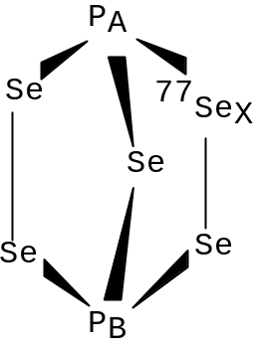

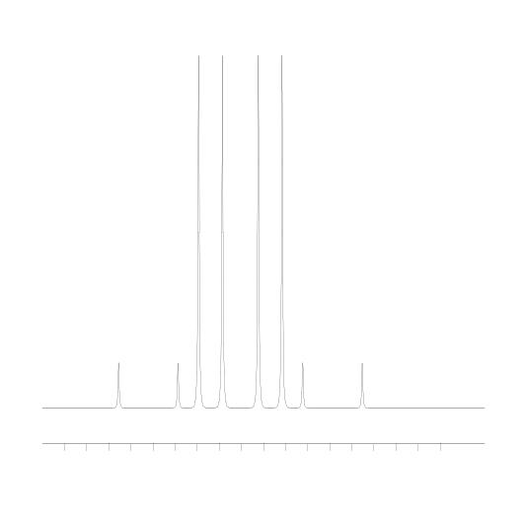
Frequency Intensity

13026.687 0.229
12891.921 0.227
12845.687 1.771
12791.836 1.771
12710.921 1.773
12657.703 1.773
12610.836 0.229
12476.702 0.227

The satellite spectrum consists of two superimposed AB sub-spectra, with the same J_{AB}, since m_{X} is a ‘good quantum number’. Recall equation (1):
ν_{A}* = ν_{A} + m_{X}J_{AX} (1)
Now we have the same thing for P_{B}:
ν_{B}* = ν_{B} + m_{X}J_{BX} (11)
Putting them together, the sub-spectra have midpoints
midpoint_{AB}* = (ν_{A}* + ν_{B}*)/2
= (ν_{A} + m_{X}J_{AX} + ν_{B} + m_{X}J_{BX})/2
= (ν_{A} + ν_{B})/2 + m_{X}(J_{AX} + J_{BX})/2 (12)
If we define
N = (J_{AX} + J_{BX})/2 (13)
and
L = (J_{AX} − J_{BX})/2 (14)
equation (12) simplifies to
midpoint_{AB}* = midpoint_{AB} + m_{X}N (15)
i.e.
midpoint_{AB}⁺ = midpoint_{AB} + ½N (16)
midpoint_{AB}⁻ = midpoint_{AB} − ½N (17)

Similarly, from equation (4) the subspectra have effective δ’s:
δ_{AB}* = ν_{A}* − ν_{B}*
= ν_{A} + m_{X}J_{AX} − ν_{B} − m_{X}J_{BX}
= ν_{A} − ν_{B} + m_{X}(J_{AX} − J_{BX}) (18)
i.e.
δ_{AB}⁺ = δ_{AB} + L (19)
δ_{AB}⁻ = δ_{AB} − L (20)

All you need to do is to find the two AB sub-spectra + and −; find the midpoint and δ for each and plug them into the left sides of equations (16), (17), (19) and (20); solve the pair of equations (16) and (17) to get midpoint_{AB} and N; solve the pair of equations (19) and (20) to get δ_{AB} and L; solve the pair of equations (13) and (14) to get J_{AX} and J_{BX}; and finally find ν_{A} and ν_{B} from midpoint_{AB} and δ_{AB} as in Problem 2. All of the equations can be solved just by adding or subtracting them and perhaps dividing by two.
Start by considering the leftmost small peak: it must be the left peak of one sub-spectrum. To which big peak must J_{AB} be measured? Calculate J_{AB} from the table listing.

3(a) ²J_{AB} = Hz

It is big for a ²J(PSeP)! Mark the two peaks you have used as L for left side of a sub-spectrum. J_{AB} occurs twice per sub-spectrum (equation (5)) and there are two sub-spectra, so now find the other three occurrences of J_{AB}, i.e. the same splitting three more times. Mark the peaks as L or R appropriately. Now to find the two complete sub-spectra, you have to match up a left side with a right side for each. In this example, there is only one possible solution, otherwise you will get your left and right big peaks crossed over: mark all four peaks of one sub-spectrum with X and the other with Y. In general, you might have to make sure that the tenting on each side of a sub-spectrum matches, as in equation (6). You have not used + and − to mark the sub-spectra (yet) because you do not know the signs of the couplings. However, you can avoid some of the abstraction if we tell you some information which has been known for quite a long time: ¹J_{AX} between a three-coordinate phosphorus and a two-coordinate selenium is known to be negative, and is likely in this molecule to be numerically much larger than ²J_{BX}, which might have either sign. From equation (13), what is the sign of N?

3(b) Sign of N is:

From equation (14), what is the sign of L?

3(c) Sign of L is:

So from equation (16), is the + sub-spectrum the high frequency (left) one or the low frequency (right) one?

3(d) The + sub-spectrum is the one

In the following, carry the three decimal places of Hz through your calculations, to avoid losing too much precision. Find midpoint_{AB}⁺ and δ_{AB}⁺ as in Problem 2. When you find δ_{AB}⁺, you take a square root, so the result could have either sign. But you know that A and B are nearly chemically equivalent, so δ_{AB} is very small, and you know the sign of L. Therefore from equation (19) you know the sign of δ_{AB}⁺. Make sure you get it right!

3(e) midpoint_{AB}⁺ = Hz

3(f) δ_{AB}⁺ = Hz

Now do the same thing for the − sub-spectrum (considering equation (20)!):

3(g) midpoint_{AB}⁻ = Hz

3(h) δ_{AB}⁻ = Hz

Solve equations (16) and (17):

3(i) midpoint_{AB} = Hz

3(j) N = Hz

Solve equations (19) and (20):

3(k) δ_{AB} = Hz

3(l) L = Hz

Solve equations (13) and (14):

3(m) J_{AX} = Hz

3(n) J_{BX} = Hz

¹J_{AX} should come out with the correct sign. ²J(³¹P⁷⁷Se) couplings are a bit uncommon! Solve equations (9) and (10):

3(o) ν_{A} = Hz

3(p) ν_{B} = Hz

As you see, δ_{AB} is not quite zero: i.e. P_{A} and P_{B} are not quite chemically equivalent because the ⁷⁷Se with a different nuclear mass is not placed symmetrically with respect to them. Because of anharmonic vibrations, the slightly different mass causes a slightly different electron distribution and hence different phosphorus chemical shifts. This effect is called a secondary isotope shift, and is reported in ppb (parts per billion, i.e. in 10⁹). These shifts can be found to this accuracy because ν_{A} and ν_{B} are measured in the same solution at the same time. Give δ_{AB} in ppb to one decimal place.

3(q) δ_{AB} = ppb

The AB₂ system
This is much easier! Here atom A sits on an element of symmetry (e.g. a C₂ axis or more often a mirror plane) which relates the two atoms B, so that A couples equally to each B. The B atoms are chemically and magnetically equivalent. In the X limit we have an AX₂ system, which consists of a 1:2:1 triplet for A and a 1:1 doublet for X. When J_{AB}/δ_{AB} is small, there are more peaks (eight) and the spectrum is no longer recognisable as a triplet and doublet. However, the appearance depends only on J/δ, so by simulating several values using a computer program (or looking up pictures in a textbook) it is usually possible to assign the peaks. Here is the picture for J/δ=0.5, with ν_{A}>ν_{B}. If ν_{A}<ν_{B}, it would be back to front, because, unlike an AB spectrum, it is not symmetrical.

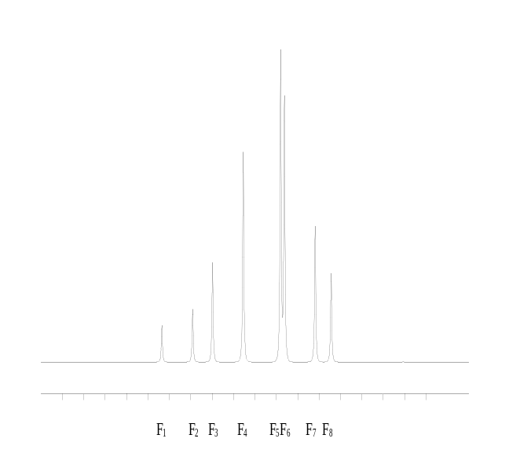

Frequency Intensity

218.614 0.368
146.692 0.531
100.000 1.000
28.078 2.106
−59.464 3.101
−68.614 2.632
−140.536 1.363
−178.078 0.894

To find the parameters, use the following equations:
ν_{A} = F₃ (21)
ν_{B} = (F₅ + F₇)/2 (22)
|J_{AB}| = (F₁ − F₄ + F₆ − F₈)/3 (23)
As for an AB spectrum, the appearance does not depend on the sign of J_{AB}, so you cannot find this sign. Notice that, although in the X limit lines 2 and 3 merge to form the centre of the triplet, ν_{A} is not the average of F₂ and F₃. Likewise, although the four lines 5–8 become the doublet in the X limit, ν_{B} is not the average of all four of them.

Problem 4
For the provided ‘dummy’ spectrum:

4(a) ν_{A} = Hz

4(b) ν_{B} = Hz

4(c) J_{AB} = Hz

4(d) δ_{AB} = Hz

(It should be double J_{AB} in this case!) To recognise AB₂ sub-spectra in sub-spectral analysis (or if the spectrum is overlaid by another compound), some equal splittings rules can help to identify the lines which belong to a particular sub-spectrum. Using a ruler or (better) dividers or a pair of compasses, look for two splittings equal to F₁−F₂, and confirm your answers using the listing. Write them as formulae, e.g. F₁−F₂, F₃−F₄, etc.

4(e) Splittings equal to F₁−F₂ are:

Do the same for F₁−F₃.

4(f) Two splittings equal to F₁−F₃ are:

You will use these relationships in the next problem.

The AB₂X system
Now for another real molecule, in which you can practise the sub-spectral analysis learnt for ABX, but recognising AB₂ sub-spectra. There are no square roots involved and you can see immediately the signs of δ_{AB}⁺ and δ_{AB}⁻ by which way round their AB₂ sub-spectra are. In this respect, AB₂X is easier than ABX. The added difficulty is in finding each sub-spectrum.

Problem 5

This example continues to follow the theme of a ⁷⁷Se satellite spectrum in a ³¹P spectrum, this time for AsP₃Se₃ with the structure shown. The main ³¹P spectrum will be for molecules with no ⁷⁷Se. They have C_{3v} symmetry which makes all three phosphorus atoms equivalent, giving a single line. The molecule shown, with one ⁷⁷Se, has only C_{s} symmetry, with the mirror plane through As, ⁷⁷Se and P_{A}, and relating the two P_{B} atoms. 20% of the molecules will have one ⁷⁷Se. This satellite spectrum appears as shown.
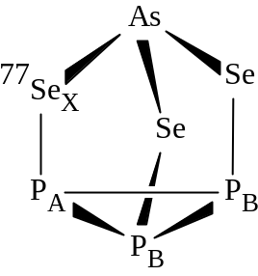

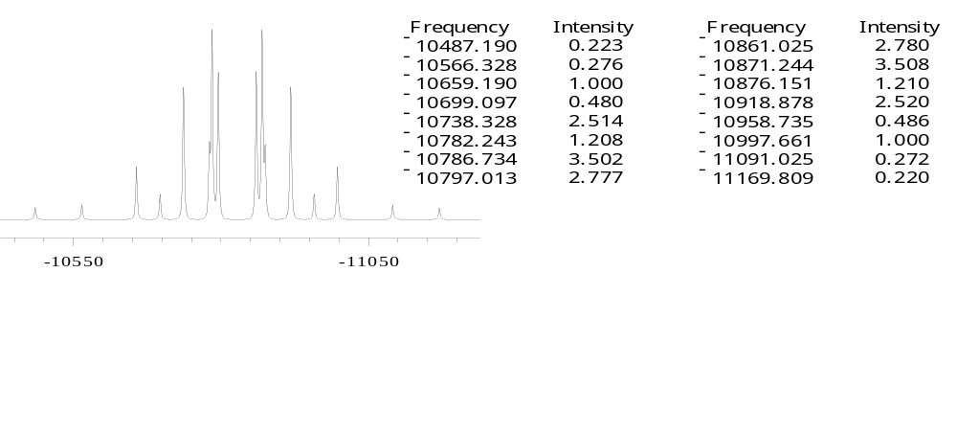

By comparing this spectrum with the ‘dummy’ AB₂ spectrum above, you should be able to see that it is made up of two AB₂ sub-spectra (one for each spin state of X), the opposite way round to each other, with their B ends overlapping and their A ends sticking out on either side. As in Problem 3, ¹J_{AX} is expected to be large and negative, while ²J_{BX} should be smaller and could be of either sign. ¹J_{AB} is between two three-coordinate phosphorus atoms, so is also known to be negative.

Looking at equations (2) and (3), which subspectrum, + or −, will have its A end at the high-frequency end of the spectrum?

5(a) The highest frequency peak will belong to:

Now start marking off the peaks as + or −, starting from the outside, and testing the splittings with the equal splitting rules you discovered in Problem 4. You should be able to see which must be the F₈ peaks of each subspectrum, and from this you can assign the F₅, F₆ and F₇ peaks in the most heavily overlapped region. Now use the peak listing and the AB₂ rules in equations (21)−(23) to find ν_{A}*, ν_{B}* and J_{AB} for each sub-spectrum:

5(b) ν_{A}⁺ = Hz

5(c) ν_{B}⁺ = Hz

5(d) J_{AB}⁺ = Hz

5(e) ν_{A}⁻ = Hz

5(f) ν_{B}− = Hz

5(g) J_{AB}⁻ = Hz

The two values for J_{AB} should be numerically the same, and you know the actual sign.
Solve equations (2) and (3):

5(h) ν_{A} = Hz

5(i) J_{AX} = Hz

and the corresponding equations for P_{B}:

5(j) ν_{B} = Hz

5(k) J_{BX} = Hz

Notice the negative ³¹P chemical shifts, typical for phosphorus in a three-membered ring. Using the operating frequency 121.499 MHz, calculate δ_{AB} in ppb.

5(l) δ_{AB} = ppb

The AA′XX′ system
This, or more commonly AA′MM′ where A and M are the same nuclear species, is a spin system often met with in ¹H NMR of organic compounds or in ³¹P NMR of symmetric inorganic molecules. Suppose two nuclei, A and A′, are related by molecular symmetry so that they have the same chemical environment and hence the same chemical shift exactly. They are said to be chemically equivalent. But now suppose that A has a different coupling to X than A′ has to X. This makes A magnetically non-equivalent to A′, because for a particular spin state of X it will absorb at a different effective chemical shift to A′. A and A′ are said to be a chemically equivalent but magnetically non-equivalent pair. The definition of magnetic non-equivalence is that A and A′ are magnetically non-equivalent if they couple differently to any nucleus at a different chemical shift to themselves. We will be able to measure the coupling between A and A′, in contrast to a magnetically equivalent pair A₂. If J_{AA′} is not zero, but δ_{AA′} is zero because A and A′ are chemically equivalent, then J/δ is infinity and the spectrum is infinitely non-first order, and does not look at all like a spectrum of first order multiplets, even when A and X are different nuclear species. However, an AA′XX′ spectrum (or a AA′MM′ spectrum where ν_{A} and ν_{M} are fairly far apart) consists of AB sub-spectra, and it is quite easy to analyse it using a hand calculator, using a set of rules peculiar to the AA′XX′ spin system. Quite often this gives more accurate values of couplings (compared with the final results of doing a computer fit) than does solving an ABM system as ABX using subspectral analysis as in Problem 3 above.

Problem 6

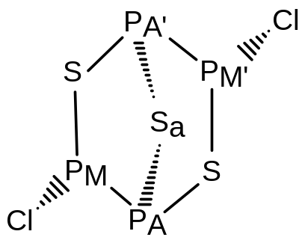This example of a AA′MM′ ³¹P spin system is easily understood. The molecule has a C₂ symmetry axis through S_{a}, which rotates P_{A} into P_{A}′, making them chemically equivalent (both are bridgehead atoms), while it rotates P_{M} into P_{M′}, making them a second chemically equivalent pair (both carry a chlorine substituent). P_{A} and P_{A}′ are magnetically non-equivalent because they couple differently to P_{M}. J(P_{A}P_{M}) is a ¹J coupling, whereas J(P_{A′} P_{M}) is a ²J coupling through sulfur. It does not matter that P_{A}′ has a ¹J coupling to P_{M′} which is equal to ¹J(P_{A}P_{M}) because of the C₂ symmetry: the condition for magnetic non-equivalence is simply that there should be a coupling to one other nucleus, which is different for the two candidate atoms. By an exactly parallel argument, P_{M} and P_{M′} can be shown to be also a magnetically non-equivalent pair.

Here are simulations of the two multiplets in the ³¹P NMR spectrum of this compound.
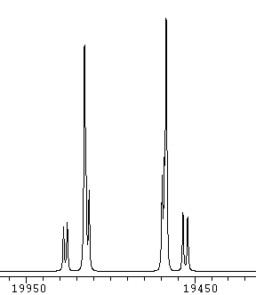 |  | 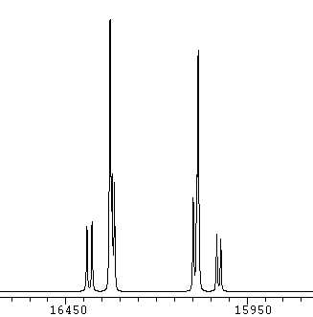
P_{M}, P_{M′} |  | P_{A}, P_{A′}

You see that (except for slightly poorer resolution in the P_{M} multiplet, caused by the kind of chlorine coupling relaxation mentioned in Problem 2) the two multiplets are mirror images of each other. All of the coupling information is contained in both of them, so that, except for obtaining chemical shifts for each, you need analyse only one of the multiplets, in this case the P_{A},P_{A′} multiplet. The corollary is that you cannot tell which chemical shift is which by associating a coupling of a particular size with one rather than the other, as you could in a more or less first order spectrum.

The multiplets are tented because ν_{A} and ν_{M} are not an infinity apart. In a true AA′XX′ system there is no tenting, and the two tall peaks of each multiplet have the same height as each other. An AA′XX′ multiplet has a mirror plane of symmetry down the middle of it, so the peak positions in each half are exactly symmetrically placed. If you look closely here, you can see that in the P_{A},P_{A′} multiplet, two peaks are resolved to the right of the left hand tall peak, whereas one of the corresponding peaks is only barely visible as a shoulder to the left of the right hand tall peak. Fortunately, our NMR spectrometer was able to find the position of this peak, making this example more suitable for hand analysis here.

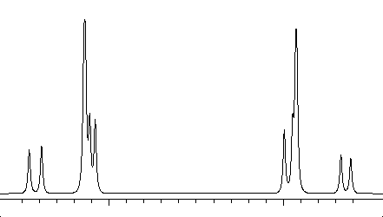
Here is an expansion plot of the P_{A} P_{A′} multiplet.
Frequency | Intensity
16392.0 | 0.825
16377.8 | 0.890
16328.0 | 3.267
16322.3 | 1.503
16316.0 | 1.397
16098.8 | 1.197
16089.0 | 1.511
16085.0 | 3.088
16033.8 | 0.731
16022.5 | 0.670

The two tall peaks of the P_{M} P_{M′} multiplet are:
You can analyse this multiplet as if it were for an AA′XX′ system, as follows. This is called ‘taking the X approximation’. First, see that the multiplet consists of two strong peaks, and eight other peaks which constitute two AB sub-spectra, which have the same midpoint and the same δ_{AB}* as each other, but different J_{AB}*. If we call the eight frequencies F₁ – F₈, then F₁, F₄, F₅ and F₈ are sub-spectrum 1, and F₂, F₃, F₆ and F₇ are sub-spectrum 2.
Frequency | Intensity
19777.5 | 3.066
19535.0 | 3.464

We define four auxiliary parameters to help in the calculation, as follows. Notice that the definitions of N and L are similar to but subtly different from those for an ABX system, given in Problem 3 above. (Some textbooks use the same definitions for both systems, but that introduces some factors of 2 elsewhere in the AA′XX′ procedure.)
N = J_{AX} + J_{AX′} (24)
L = J_{AX} - J_{AX′} (25)
K = J_{AA′} + J_{XX′} (26)
M= J_{AA′} - J_{XX′} (27)
The chemical shifts ν_{A} and ν_{X} are simply the midpoints of the two completely symmetrical multiplets of the AA′XX′ system. In our AA′MM′ system, make the approximation that the chemical shifts are the averages of the frequencies of the two strong peaks in each multiplet.

6(a) ν_{A} = Hz

6(b) ν_{M} = Hz

The separation of the two strong peaks (in either multiplet) is N. As this is just a separation, we cannot tell the sign of this for an AA′XX′ system, without knowledge from elsewhere. In the present molecule, we know that J_{AX} is a large and negative ¹J coupling (because it is between two three-coordinate phosphorus atoms) while J_{AX′} is a smaller ²J coupling.

From equation (24)

6(c) Sign of N is:

Using frequencies for the P_{A} P_{A′} multiplet

6(d) N = Hz

The δ_{AB}* for any of the four AB sub-spectra is L. Again, this is just a separation, so we cannot tell its sign, but in equation (25) we can use previous knowledge about signs and magnitudes of the terms in the same way as for N.

6(e) Sign of L is:

For the P_{A} P_{A′} multiplet, use equation (8) (with the appropriate peak numbering substituted) to find δ_{AB}* for each of the two AB sub-spectra.

6(f) δ_{AB}* (sub-spectrum 1) = Hz

6(g) δ_{AB}* (sub-spectrum 2) = Hz

They should be about the same. Here, because of the shoulder in sub-spectrum 2, whose peak top will be at a slightly different frequency from the transition frequency causing it, just take δ_{AB}* for sub-spectrum 1 as the best magnitude for L.

6(h) L (including the correct sign) = Hz

Now that you have the values of N and L, solve equations (24) and (25) to obtain J_{AX} and J_{AX′}

6(i) J_{AX} = Hz

6(j) J_{AX′} = Hz

Although the two AB sub-spectra in each multiplet have the same δ_{AB}*, they have different apparent AB couplings J_{AB}*. These are K and M in equations (26) and (27), but for an AA′XX′ system we do not know which is which or what is the sign of either.

Use equation (5) (with the appropriate peak numbering substituted) to find J_{AB}* for each of the two AB sub-spectra.

6(k) J_{AB}* (sub-spectrum 1) = Hz

6(l) J_{AB}* (sub-spectrum 2) = Hz

An AA′MM′ system can yield more information than an AA′XX′ system, because, if iterative fitting of the observed spectrum is done with a computer program such as NUMARIT, starting with values obtained by the present method for the shifts and couplings, different relative signs for J_{AA′} and J_{XX′}, relative to the J_{AX} , J_{AX′} combination, will give different reported qualities of fit. Often this can be seen visually in the resulting plots of the simulated spectra. The best fit to the observed spectrum should be the one with the correct assignment of signs of couplings. The more poorly the X approximation works for an AA′MM′ system, the better is the quality of information about signs of couplings, obtained from the computer fitting.

The best way of starting to sort out which is K and which is M, and what their signs are, is to use information from related compounds about the relative sizes and signs of J_{AA′} and J_{XX′}. If similar compounds are known, or can be synthesised, in which the twofold symmetry is broken, then couplings of particular relative size can be associated with atoms with particular relative chemical shifts. Although the spectrum would not then be non-first order by symmetry, if some chemical shifts are sufficiently close together by accident, so as to make the spectrum non-first order, then relative quality of computer fits can still give relative signs, without the need for selective decoupling experiments. In the present case it was possible to make α-P₄S₃BrI, from which it was found that ²J(PSP) between the bridgehead atoms (corresponding to J_{AA′} in the present compound α-P₄S₃Cl₂) was positive and much larger in magnitude than ³J(PSPP) (corresponding to J_{XX′} in the present compound), which also was positive.

Using this information in equations (26) and (27), what is the sign of both K and M? Assign the two values for J_{AB}* to K and M, applying this sign information.

6(m) K = Hz

6(n) M = Hz

Solve equations (26) and (27) to obtain J_{AA′} and J_{XX′}.

6(o) J_{AA′} = Hz

6(p) J_{XX′} = Hz

Note that if J_{XX′} had the opposite sign, the allocation of K and M to the two values of J_{AB}* would simply be swapped over, with no change in the resulting spectrum in the pure AA′XX′ case. This means that even if the sign of J_{AA′} can be allocated by comparison with other compounds, J_{XX′} can still have either sign. In the α-P₄S₃R₂ series, computer fitting of spectra shows that for R = hydride, cyanide, amide or thiolate, ³J_{MM′} is negative, while for R = halide (as here), ³J_{MM′} is positive. Molecules with two different substituents show values which are averages of this coupling in the symmetric compounds, taking into account these signs.

