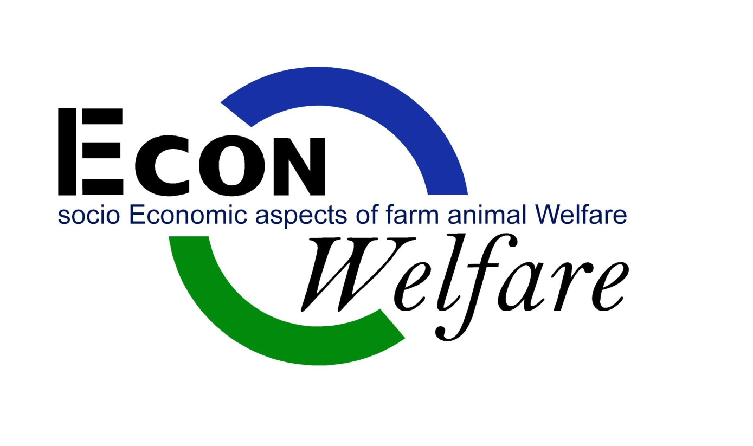
DRAFT
Not for further circulation

Deliverable number 4.3

Impacts of improved animal welfare standards on international trade and competitiveness of EU animal production.

David Harvey and Carmen Hubbard

List of contributors

NL: Animal Sciences Group Veehouderij B.V. (WUR-ASG)
Hans Spoolder Ph.D., Martien Bokma, M.Sc., Anke de Lorm
Landbouw-Economisch Instituut B.V. (WUR-SSG)
Gé Backus Ph.D., Paul Ingenbleek Ph.D., Victor Immink M.Sc.
IT: Centro Ricerche Produzioni Animali SpA (CRPA)
Kees de Roest Ph.D., Franco Torelli M.Sc., Alberto Menghi M.Sc., Paolo Rossi M.Sc., Paolo Ferrari M.Sc.
CH: Forschungsinstitut für biologischen Landbau (FiBL)
Otto Schmid, Jürn Sanders Ph.D., Rahel Kilchsperger
PL: Szkoła Główna Gospodarstwa Wiejskiego (SSGW)
Edwards Majewski Ph.D., Waldemar Guba M.Sc., Agata Malak-Rawlikowska Ph.D., Monika Gebska, Ph.D., Mariusz Hamulczuk, Ph.D.
SE: Sveriges Lantbruksuniversitet (SLU)
Linda Keeling Ph.D. (workpackage coordinator WP3), Lotta Berg Ph.D., Frida Lundmark M.Sc.
UK: University of Newcastle upon Tyne (UNEW)
Jonathan Guy Ph.D. (co-chair workshop Madrid), David Harvey Ph.D., Sandra Edwards Ph.D., Guy Garrod M.Sc., Philip Cain Ph.D., Carmen Hubbard Ph.D., Kamara Scott
ES: Universidad de Extremadura (UNEX)
Miguel Angel Aparicio Tovar Ph.D., Juan de Dios Vargas Ph.D., Jurgen Robledo Ph.D., Francisco J. González Ph.D., Luís Prieto Ph.D., Diana Villanueva Ph.D.
MK: University ‘St. Cyril and Methodius’ (UKIM)
Vlatko Ilieski Ph.D., Snezana Ristovska-Jovanovska Ph.D., Aleksandra Martinovska
Stojceska Ph.D., Ivanco Naletoski, Ph.D., Blagica Sekovska, Ph.D.

We would like to thank all project partners that carried out the documentation in their country.

Acknowledgements

This report was produced with financial support from the FP7 programme of the European Commission for the project “Good animal welfare in a socio-economic context: Project to promote insight on the impact for the animal, the production chain and European society of upgrading animal welfare standards (EconWelfare)”.

The text of this report represents the authors' views and does not necessarily represent a position of the European Commission who will not be liable for the use made of such information.

Table of Contents
Word did not find any entries for your table of contents.
In your document, select the words to include in the table of contents, and then in the Formatting Palette under Styles, click a heading style. Repeat for each heading that you want to include, and then insert the table of contents in your document. You can also create a table of contents by clicking the Create with Manual Formatting option and then type the entries manually.

List of Tables

Background
Econ-Welfare is a response to the 7th Framework Programme call KBBE-2007-1-4-15: “Assessing the socio-economic consequences of measures promoting good animal welfare”. Central to this call is the need to support development of European policies implementing the Community Action Plan on the Protection and Welfare of Animals. Our project (Econ-Welfare) has as its overall objective: “to reveal what policy instruments might be effective in the route towards higher animal welfare representing the concerns of civil society and in which competitiveness of the livestock industry is guaranteed.”
As originally conceived, WPs1, 2 and 3 were expected to define a short list of specific upgrades to current animal welfare standards as evidenced by extensive stakeholder engagement under the work-packages. The socio-economic consequences of these specific improvements in animal welfare standards were then to be assessed under WP4. In the event, it became clear that such a short list of specific improvements was not appropriate, or even possible to identify, as Europe’s member states and segments of the supply chains move at different speeds towards higher levels of animal welfare, and different short lists apply to different regions, sectors (species), market segments and countries. As described in previous deliverables, more general policy approaches and instruments have been identified, and their general strengths and weaknesses explored (D3.1). These approaches (objectives, instruments and indicators) have been assessed and ranked by stakeholders (D3.2 and 3.3), and subsequently logically ordered to reflect the current conditions of animal welfare in each country or sector in D3.4. However, the diversity of conditions and differential rankings prevented any quantitative analysis of the potential consequences of these objectives or instruments.
We have illustrated the economic consequences at the farm level of indicative improvements in animal welfare conditions (as pre-defined specific standards, each of which is comprised of a number of detailed norms (D4.1)). However, identification of the consequences of such detailed changes throughout the supply or marketing chain, and further to international competitiveness, is more problematic. The identification of the consequences requires some systematic or consequential framework. The consequences of specific changes can then be isolated within this framework. Since the specific consequences follow directly from the framework, it is the framework itself, rather than the specific consequences, which are of value.
D4.2 addressed the consequences of improved animal welfare standards on the supply or marketing chain. In D4.2, we reviewed and explained the basic economic principles underlying any assessment of the consequences of improved welfare in the chain. In the case of the consumer/citizen gap in expressed attitudes and intentions with respect to improved animal welfare, and their products, we extended the analysis to address the potential salience of this gap for the consequences of various policy and strategic initiatives to improve welfare. In particular, we explained in D4.2 that animal welfare itself is not a ‘public good’ in economic terms. Rather, animal welfare conditions are reflected in ‘consumption externalities’, where my wellbeing is affected by other peoples’ consumption of (and hence production conditions of) animal products. Animal welfare conditions do generate ‘psychological externalities’ for consumers. However, these cannot be dealt with in the same manner as material (technical) externalities, as is done with environmental goods and services. D4.2 also explains that, in a competitive market, improved animal welfare will generally mean increased costs, though improved techniques and practices (through R&D, for instance) and improved efficiency and effectiveness by participants in the chain can improve both economic efficiency (reduce costs) and improve animal welfare. Society’s choices about the levels of animal welfare to tolerate and encourage are typically thought of being articulated either through government regulation and intervention, or through the market. However, our analysis in D4.2 strongly suggests that both avenues are, effectively seeking to balance the advantages and disadvantages of improvement in animal welfare, and that both evolve to reflect, in different ways, the peoples’ changing preferences and judgements, both as citizens and consumers. Furthermore, this analysis also suggests that hybrids and amalgams of both apparently dichotomous routes to welfare improvements will be explored and developed.
In general, the conclusions of the analysis of D4.2 strongly support the findings of the previous work packages in this project – that variation in political and market conditions, as well as amongst the species and production conditions, mean that there is not and cannot be any substantive single ‘solution’ to improving animal welfare in the EU. Rather, different mixtures of public-private partnerships will be needed, as have already emerged in various parts of the EU, especially to: develop specific, third-party verified standards for use by the private sector in developing markets for animal welfare products; improve both public and chain information and communication.

This Deliverable (4.3) addresses the consequences of improved animal welfare for international trade and competitiveness, which also ‘all depend’ on the specific improvements considered and on the contexts and circumstances within which these improvements are made.

The expectation at the outset of the project was that WPs 1, 2 and 3 would define a limited set of “strategic options and the coherent policy instruments” to promote animal welfare with the EU and that WP4 would examine the economic implications of this set at the farm, chain and (global) market (society) levels. However, it has become clear that there is no simple list of ‘next steps’ towards improved animal welfare, at least not in terms of a short list of specific improved practices. As noted in 3.1, “For increasing animal welfare there is not one solution that fits all countries, rather multi-use of policy instruments will be necessary to increase the level of animal welfare.” As a consequence, at least some of the intentions of our initial description of work (DoW) are no longer appropriate.

Nevertheless, we have identified illustrative improvements in standards (as sets of norms for production practices) based on D1.2 and 2.2 for analysis at the farm level (D4.1). Here, we examine the consequences of the associated cost changes on EU self-sufficiency levels (changes in net-trade positions) by country using the Agmemod model.

It would clearly be useful to provide a (set of) template economic assessment tools with which to evaluate the economics of improving animal welfare. However, such assessments are necessarily highly specific to the particular welfare improvement practices, regulations, codes and institutions being considered. There is no simple template available, and there is good reason to suppose that no useful template(s) can be constructed, certainly not at the level of EU and international markets (see Harvey, 2009, EconWelfare Questions, and also EconWelfare – Newcastle University contribution to Deliverable D2.6, August, 2010).
Nevertheless, the fundamental ‘social physics’ of international trade and of the economic conception of competition certainly illuminate the essential structure of the consequences of improved animal welfare standards. The next section outlines and explains these fundamentals.
Economic Principles
Figure 1 shows the basic analysis of international trade and market interaction, and the consequences of improved animal welfare standards in the EU. The left hand panel of Figure 1 shows the EU market demand (EUD) and EU market supply (EUS₀) for animal products. Consumers will generally purchase more products the lower is the price, other things being equal, and vice versa – EUD slopes downwards to the right, the lower the price, the greater the quantity demanded. On the other hand, EU suppliers can only be persuaded to produce more output if they are paid more. Producing more requires more inputs and more intensive use of factors of production, all of which have other alternative uses and occupations. Persuading more of these inputs and factors of production to be employed in producing animal products means out-bidding their alternative opportunities, and generally raises the costs of production as more is produced, at least at the market level. EUS₀ slopes upwards to the right.
Figure 1 Simple Economics of improved animal welfare standards in Europe

A competitive market equilibrium within the EU, ignoring the possibility of international trade with third countries, would result in an equilibrium between EU supply (EUS) and EU demand (EUD). Quantities produced and consumed and the equilibrium price would be determined by the intersection of these two ‘curves’ (illustrated here as straight lines). However, international trade is both possible and frequent. The interaction between the EU and the Rest of the World (RoW) is shown in the right hand panel of Figure 1. In this panel, we measure trade volume on the horizontal axis, rather than quantities supplied and demanded as in the left panel. The curve (line) EUXS₀ shows the EU’s excess supply (or export supply) as the difference between EU supply and EU demand at each and every price. EUXS₀ intersects the vertical axis of the right hand panel (the point of zero trade with the rest of the world) at the autarchic EU price - the price at which EU demand is equal to EU supply. At any price above this autarchic price, the EU will be a net exporter – having a positive excess or export supply to the rest of the world. At any price below this autarchic price, the EU will be a net importer, with domestic (EU) demand being more than EU supply, so EU export supply will be negative – signifying imports rather than exports. EUXS₀ traces out this export supply relationship.
The rest of the world is included in the right hand panel in an exactly analogous fashion, where RoWXD shows the rest of the world’s excess (import) demand, as the difference between the rest of the world’s demand and supply at each and every price. International competitive equilibrium will be established by the intersection of the EU’s export supply (EUX₀) with the RoW import (excess) demand (RoWXD) in the right hand panel. As shown in Figure 1, this intersection happens at a price which makes the EU a (marginal) net exporter, and hence the RoW a net importer, with traded quantity equal to T₀, and the international price at P₀.
Of course, in practice, there are significant marketing, transport and logistic costs associated with international trade – people and businesses have to be able to earn a living carrying out trade, and will not do so unless they can earn competitive livings. These costs are ignored in the simply analysis of Figure 1, but would in practice would result in a difference, or wedge, between the import (cif) and export (fob) prices to account for the marketing and transport costs (with quantities imported and exported being equal, but the import (cif) price being higher than the export (fob) price). In addition, there are also a variety of import taxes and levies (and occasionally export subsidies) associated with international trade, which are also ignored here. Finally, international trade involves exchanging currencies, so the exchange rate will also affect the translation of the EU price (in Euros) to the world price (in other currencies), which is also ignored in this analysis. None of these details, however, affect the basic analysis.
The consequences of the introduction of a new improved animal welfare standard in the EU are also identified in Figure 1. As explained in D4.2, such improved standards will generally increase the costs of EU production, shifting the EU supply curve upwards and to the left, from EUS₀ to EUS₁. As shown here, the improved standard not only increases the average cost of production for each and all quantities supplied (a vertical shift in the supply curve), also can change the responsiveness (slope) of EU supply. More animal welfare friendly practices may well require better management expertise and skills, which are in short supply, and hence the responsiveness of EU supply to changing market conditions (shifts in demand) are likely to be reduced, as shown in Figure 1.
The improved standards not only shift the EU supply curve, but also the EU’s export supply curve, as shown in the right hand panel of Figure 1 (EUXS₀ to EUXS₁). The consequences, as shown here, are that the international market price increases from P₀ to P₁, because of the reduced EU production. This is sufficient, in this illustration, to turn the EU from being a net exporter to being a marginal net importer, as production in the rest of the world responds to the increased market price.
There are two critical implications of this analysis for the general debates about changing animal welfare standards in Europe. First, market competition is not analogous to sporting competition – the winner does not take all. Making animal production more expensive in Europe compared with the rest of the world does not mean that all animal production will cease in Europe. Most animal production in Europe will remain competitive – though there is likely to be some reduction in total EU production. Second, what we do in Europe has repercussions in the rest of the world. Our improvement of animal welfare standards will tend to reduce EU production, which will tend to increase world prices, and hence affect producers and consumers in the rest of the world.
In practice, it is impossible to observe these specific consequences of changing animal welfare standards. Many other things also affect market trades, quantities supplied and demanded, trade volumes and prices. It is practically impossible to isolate empirically specific consequences, such as those of a change in EU standards, from actually observed data. However, the analytical framework can be used to estimate the consequences, given assumptions about the responsiveness (elasticities) of European and RoW supplies and demands to changes in price.
The simple diagrammatic analysis of Figure 1 is easy to operationalise to a quantitative model as illustrated in Table 1. Here, data from Eurostat and the FAO provide information on current production, consumption and trade in the EU and the rest of the world (base 2009/2010), and on the unit value of EU exports and imports of, in this case, meat and meat preparations (processed meats, SITC -01). The unit values (total value of trade divided by total quantities) show considerable differences (€3,544/t for EU imports versus €1,634/t for EU exports). Although some difference in this direction (imports more expensive than exports) is to be expected on the basis of transport and marketing costs, the difference here also reflects substantial variations in the specific mixes of products in each case. For illustrative purposes, we have used the trade weighted average of these two prices (unit values) here, as €2,150/t.
To simulate the effects of changes in animal welfare standards in the EU (as changes in costs and supply response in the EU), some assumptions about the responsiveness of both EU and RoW supplies and demands (technically, the elasticities of supply and demand in both regions) are required. In Scenario 1 (SCEN. 1), we assume relatively responsive supplies and demands in both regions – with elasticities of supply and demand in the EU as 1.0 and -1.0 respectively, and as 1.5 and -1.5 respectively in the RoW.
To reflect the effects of the introduction of improved animal welfare standards, suppose that this increases EU costs of production by 5% (shifting EUS upwards by 5% in Figure 1), and that it reduces the responsiveness of EU supply by 5% (making the EU supply curve 5% steeper). The effects on EU and RoW production and consumption, and hence on net EU trade with the rest of the world under these assumptions are shown in column SCEN. 1 of Table 1. As can be seen, EU production falls by 10%, though EU consumption falls by only 1%, resulting in a switch from net export to net import status for the EU, as production in the RoW increases by 1%. However, consumption in the rest of the world falls by 1% as a result of the increase in the equilibrium world price (facing both EU and RoW consumers and producers) by 1%.
Table 1: Indicative Simulations of Improved Animal Welfare Standards in the EU
DATA* | Current | SCEN. 1 | (% of base) | SCEN. 2 | (% of base)
EU Production | 43,420 | 39,218 | 90% | 38,106 | 88%
EU Consumption | 41,010 | 40,785 | 99% | 40,725 | 99%
EU Net Exports | 2,410 | -1,567 | -165% | -2,620 | -209%
RoW Production | 240,470 | 242,449 | 101% | 242,972 | 101%
RoW Consumption | 242,880 | 240,881 | 99% | 240,353 | 99%
World Price (€/t) | 2,150 | 2,162 | 101% | 2,180 | 101%
ASSUMPTIONS
EU Elasticity of Supply |  | 1 |  | 0.5
EU Elasticity of Demand |  | -1 |  | -0.5
RoW Elasticity of Supply |  | 1.5 |  | 0.75
RoW Elasticity of Demand |  | -1.5 |  | -0.75
Shift in EU Supply |  | 5% |  | 5%
Change in EU Supply Response |  | -5% |  | -5%
* Note: quantities measured in ‘000t.
Since the elasticities of demand and supply illustrated in SCEN 1 might be regarded as being unreasonably high, we also show the results of halving these elasticities in SCEN 2. The effects of these changes in elasticities are relatively small in this case, with the exception of net trade, which reflects the cumulative effects of otherwise small differences in domestic (EU) and overseas (RoW) production and consumption levels. The major reduction in EU net exports (to a net import position) under SCEN 2 reflects the greater reduction in EU supplies (by 12% rather than 10%) under the more responsive elasticities of SCEN 2.
The diagrammatic analysis of Figure 1 also allows us to quantify the economic welfare effects on producers and consumers of the assumed changes. This analysis is based on the following logic. The demand curve reflects the consumers’ willingness to pay (WTP) for different quantities of consumption – showing that consumers in general are willing to pay higher prices for successively smaller quantities and vice versa. Since the competitive market determines that they only have to pay the single market price (determined by the market balance between supply and demand), it can be inferred that consumers benefit from a consumer surplus – they benefit from the fact that they are not required to pay their full willingness to pay for each and every unit, but only their WTP for the marginal unit. This consumer surplus can be measured as the area (price x quantity) above the market price line and beneath the demand curve. Increasing prices to consumers reduces their surplus, making them worse off than before, because they have to pay higher prices for all their consumption, and also respond by reducing their quantities purchased, compared with the ‘counter-factual’ policy of no change in AW standards.
On the supply side of the market, the supply curve shows the cost to the economy of producing the next (additional) unit – the marginal cost of production. Analogous to the consumer case, producers actually receive the market price for each and every unit – which pays them more than the marginal cost for all production except the marginal (last) unit, and in that sense producers also earn a surplus from their production – the producer surplus – measured in total as the area (price x quantity) below the market price line and above the supply curve. In fact, this producers’ surplus is a measure of the value-added of sector’s production, which serves to pay wages, salaries, returns on capital invested, land and property rents. While producers are driven by profits, in a competitive market equilibrium which is being analysed here, pure profits will be zero – all the value added will be used to reward the resources and factors of production (land, labour, capital and management) for their productive activities. The supply curve simply reflects the fact that these rewards will be sufficient to persuade at least some of these resources and factors to stay in the sector, rather than seek their living elsewhere. The upward slope of the supply curve thus reflects the heterogeneity of these resources, and their different earning abilities in other occupations.
Using this logic, we can measure the changes in producer and consumer surplus consequent on the changed animal welfare standard in the EU. Since we only measure the changes, the gross simplification of assuming linear supply and demand curves in Figure 1 make very little difference to the estimates of the changes. The results are shown in Table 2, expressed as proportions of consumer spending and producer revenues.
Table 2: Indicative Economic Welfare effects of improved AW standards in the EU
 | Welfare change as % of expenditure/revenues
EU Consumers | -0.5%
EU Producers | -4.6%
EU Total | -5.4%
RoW Consumers | -0.6%
RoW Producers | 0.6%
RoW Total | 0.0%
World Total | -0.8%

The clear lesson from Table 2 is that the imposition of an improved animal welfare standard, which raises EU costs of production by 5%, makes the EU as a whole worse off. Not only do producers suffer (a loss of 4.6% of their revenues), but consumers also suffer. The overall effect on the EU is a loss of economic welfare of 5.4% of revenues/expenditures. In addition, consumers in the rest of the world also suffer a loss because of the increase in world price, although their producers gain, so that on balance they are more or less unaffected. Their benefit from reduced imports (increased exports) is relatively small compared with their total consumption/production.
Of course, it could be that introducing improved standards in the EU does not actually increase the costs of production. However, for this to be the case, it must be that the improved standards actually make EU producers better off than before (or at least no worse off). This outcome would raise the question of why the competitive markets of the EU have not already discovered that improved animal welfare also improves profitability and competitiveness. The concept of competitive markets includes the presumption that producers (and consumers) will strive to do the best they can (given all their specific constraints, abilities and other preoccupations), and learn that improved standards are actually better for business themselves, without needing public intervention. For public intervention to have the effect of improving profitability and competitiveness, it would need to provide better incentives and information to producers than is already provided by the market and the commercial imperative to survive and prosper as well as possible. An implication of this outcome would seem to be that, for it to occur, producers must have been in a ‘feather-bedded’ position before the introduction – they did not need to be competitive to survive. Perhaps the provision of public support through the CAP removes too much competitive pressure to ensure that producers are actually doing the best they can to survive?
It might also be the case that the new standards would persuade consumers to pay more for animal products (shifting the EU demand curve upwards) which is not taken into account in this analysis (though it could be). There are two major reasons (see D4.2) why consumers might be persuaded to pay more for animal products simply because of the introduction of new standards: a) because of the free-rider problem, consumers will only pay more if they can be sure that others will too; b) the introduction of the new standards might also provide consumers with more reliable and credible signals of the animal welfare provenance of the products. In the limit, the additional WTP by consumers following the introduction of the new standards might be sufficient to completely offset the increased costs experienced by the producers, shifting the demand curve upwards by the equivalent amount to match the shift in the supply curve in Figure 1. Providing that consumers are able to distinguish between home and foreign supplies, a persistent gap might appear between the prices they are willing to pay for imported animal products and those they are willing to pay for domestic supplies (with higher animal welfare provenance). Nevertheless, there is no guarantee that overseas consumers would also be willing to pay this premium, so exports from the EU would then become less competitive on world markets as a consequence.
Agmemod Model of EU Agriculture
The Agmemod model is a model of EU agriculture and food demand which uses a set of econometric equations to simulate production and consumption (and hence net trade) in each of the EU member states for each of the major agricultural commodities, including animal products (dairy, beef, sheepmeat, pigmeat and eggs). The AGMEMOD model works as a system of aggregated local models and is able to produce forecasts and scenario analyses of various policy and external conditions’ changes for the Member States separately as well as for the entire EU (Donnellan et. all 2002; Chantreuil and Hanrahan 2007). The work in the project was inaugurated in 2001 by the institutions representing the Old Member States (OMS) and resulted in a coherent system of models able to produce the aggregated forecasts for the EU-15 (Chantreuil and Hanrahan 2007). In the subsequent years, the project was extended to consecutive countries willing to enter the EU (NMS), Poland among them.
Each particular country model consists of a set of sub-models of the main agricultural products: grains, oilseeds and the derived products, industrial plants, milk and dairy products, livestock and meat as well as some other, of lesser importance and more locally grown products. The variables entering in each sub-model represent consecutive positions in the supply/demand balance sheet of each market. On the supply side the beginning stocks, production and imports are included, and on the demand side domestic use, exports and ending stock are modelled. The respective domestic prices (market-clearing prices) are modelled for each product in each country, and also for the whole EU. The EU net export variable is used as the closing variable at the EU level, with net exports being adjusted to ensure EU equilibrium prices. The necessary solution condition for the model is that the equality between supply and demand in each market (including net trade as the balance between exports and imports) in each country must hold. The general structure of the model is shown in Figure 2.
The disaggregation of the agricultural sector into the specific markets as well as the decentralisation of the model allows the instruments of the CAP to be modelled in a very detailed manner. The instruments range from market-specific (quotas, subsidies, production levies, coupled payments) to more general ones, such as decoupled payments. Their influence can be traced in each market separately and the specificity of the agricultural policy in each member state is taken into account. This huge advantage of partial equilibrium models such as AGMEMOD allows the analysis and simulations of a large spectrum of policy changes [AGMEMOD … 2005]. In this case, we model the stylised representations of changes in animal welfare standards, which are handled as changes in the costs of production, following the analysis of D4.1 of farm cost changes of illustrative changes in animal welfare standards. For those EU member states not participating in Econ Welfare, for which we have no independent assessments of the changes in costs, we have assumed that their cost changes are the same as those estimated for similar participating countries.
Figure 2. Structure of the AGMEMOD model
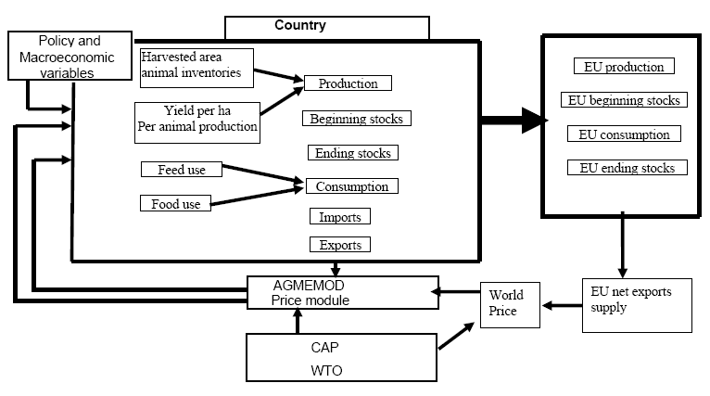
Source: Chantreuil F., Tabeau A., Van Leeuwen M. (2008).
Agmemod Model Results.
Figures 3 – 7 show the % changes in self-sufficiency in each country (except for milk, where the change is in production) generated by the Agmemod model, as a result of changing the average costs of production in each member state according to the results generated in the farm level cost benefit analyses reported in D4.1 (Figures 10 – 14). The results for the partner countries in Econ Welfare have been assumed to apply to non-partner countries based on similarities between the partners and non-partners. As noted in D4.1, the indicative standards analysed at the farm level for dairy cows actually generated cost reductions at the farm level, rather than cost increases, since the adoption of the standards was estimated to improve productivity and yields rather than reduce them.
Given the illustrative analysis above, where a 10% increase in EU costs generated a substantial change in net trade for the EU as a whole, of between 165 and 210%, the Agmemod model is far less sensitive to changes in EU costs, showing much smaller changes in net trade to substantially larger changes in costs.
Figure 3: Agmemod results Figure 4: Agmemod Results
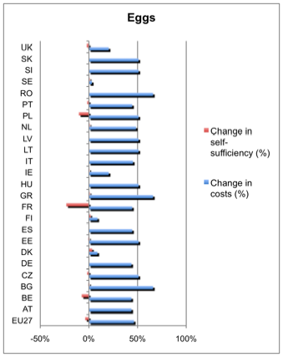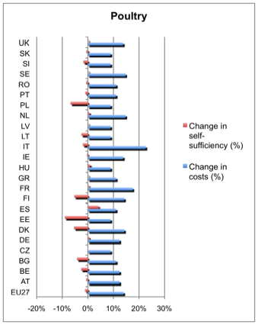

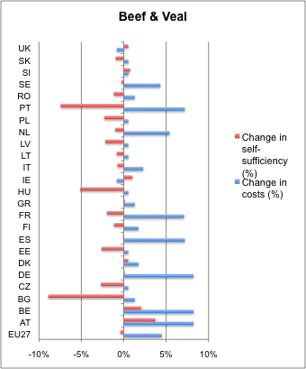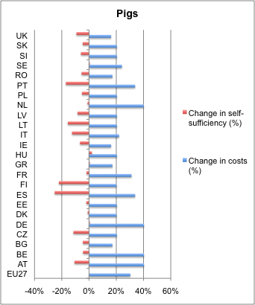Figure 5: Agmemod results Figure 6: Agmemod Results

It should be noted that Agmemod relates market-clearing prices within the EU and between the EU and the rest of the world in a rather more complex fashion than was illustrated in the simple diagrammatic analysis above. In Agmemod, market prices are driven by econometrically estimated price relationships. In particular, the elements of the supply/disappearance (demand) balances – opening stocks, production, imports for supply, and closing stocks, consumption and exports for demand – are each represented by estimated (or constructed) equations capturing the relationships between these variables and the member state market price for each commodity (and other determining variables as appropriate).
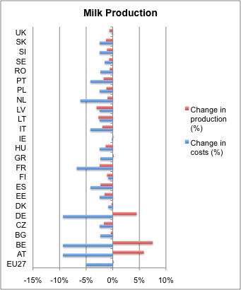Figure 7 Agmemod Results.
In general, each country’s market equilibrium is achieved through the supply/disposition balance, with price-linkage equations which relate price in each member state to the self-sufficiency ratio (production divided by domestic use) in each member state, to the previous year’s market price and some other exogenous variables such as exchange rates, tariff rates, the EU’s intervention prices for the commodity and the world price for the commodity. These linkage equations represent the price relationships between each member state market and the rest of the EU and the world market (Salamon, 2008, equations 23 and 24). As a result, price determination and transmission within Agmemod is considerably dampened compared with the simple diagrammatic analysis above.
However, as Figures 3 – 7 illustrate, there is no simple correspondence between the costs changes in each member state and the consequences for self-sufficiency ratios (or domestic production in the case of dairy). The consequences depend on, inter alia, the relative changes in domestic (member state) costs, relative to both other commodities within each member state and their substitutability or complementarity with each other on both the supply and demand sides of the market, and also on the relative changes between member states and with the rest of the world. The specific effects depend on a complex way on these relationships within the Agmemod model, and also (of course, and probably somewhat differently) in the real world.
International Agreements and Trade Law
The European Commission already documents considerable discussion and activity in the area of animal welfare and international trade, which is not repeated here. The OIE is the lead international organisation for the development and implementation of international standards of animal welfare. The OIE Guiding Principles on Animal Welfare were included in the OIE Terrestrial Animal Health Code (Terrestrial Code) in 2004. Although the specific codes addressing animal welfare remain rudimentary at this level, there is evidence that the issues are moving up the OIE agenda, with current discussions focusing on intensive poultry and beef.
FAO held an Expert Meeting on ‘Capacity Building to Implement Good Animal Welfare Practices’, in September/October 2008. Expert Meetings are a normal part of FAO practice and are used to guide the organization on how to proceed in areas where new activity is anticipated. One major outcome of this meeting is the establishment of the Animal Welfare Portal. The FAO meeting’s other recommendations were:
- to support good animal welfare practices in countries with less developed economies, the FAO should give priority to practices that lead to benefits for both people and animals,
- animal welfare should be treated as one among many socially important goals,
- animal welfare should be integrated into existing FAO programmes,
- FAO staff should attempt to understand and engage with the people who work with animals, and facilitate their own innovation and problem-solving,
- improving the welfare of animals should begin with an assessment of the risks and opportunities and a search for practical improvements,
- FAO should facilitate access by Member Countries to the findings of animal welfare research,
- FAO should consider working with other organizations to provide assistance on animal welfare legislation,
- the FAO work in full cooperation with the OIE and other organizations with capabilities that complement its own.
The EU, Council of Europe and the OIE adopted a joint declaration on Animal Welfare in November 2006 in which all three bodies commit to providing mutual support and cooperating on all aspects of animal welfare, from the elaboration of legislation, to the training of veterinary professionals and para-professionals, to raising public awareness of the societal value of animal welfare. The important link between animal welfare and the need for adequate scientific and veterinary expertise is stressed in the document. Furthermore, the Declaration commits to efficiently assisting countries to comply with, develop or enforce animal welfare laws, standards and guidelines at a national level.

The ‘simple’ story about animal welfare and international trade is that present international trade rules and obligations under the WTO do not allow countries or the EU to discriminate between otherwise “like‟ products on the basis of their production process (e.g. animal welfare conditions). If the EU wishes to increase the level of animal welfare for producers and the chain within the EU, it cannot (according to this story) then restrict imports from third countries which are not produced to the same animal welfare standards. Hence, improving standards in the EU risks reducing domestic EU production at the expense of less welfare friendly imports, as illustrated above.
However, in practice the WTO trade rules are subject to ongoing case law, and remain subject to wide interpretation. The practical definition of ‘like’ products is critical, with at least some interpretations indicating that consumer tastes and habits should be taken into account in determining ‘likeness’. If, in practice, consumers do not view two products as like each other (for example, because one has been produced humanely while the other has been produced in a way that entails serious animal welfare problems) the products could then be considered as different, rather than ‘like’ each other. If so, then the EU would be able to discriminate between foreign and domestic (EU) products on the basis of the welfare conditions applying to the source animals. Further, WTO case law has in recent years given greater weight to the Exceptions set out in Article XX of the General Agreement on Tariffs and Trade. Indeed this has been accepted by the EU Council who included a requirement in the 2009 Slaughter Regulation that meat imported from third countries must be derived from animals that have been slaughtered to welfare standards equivalent to those of the EU.
As the analysis in D4.2 showed, if consumers do both recognize (with appropriate labels and provenance) that EU animal products are produced and processed with enhanced animal welfare and also value these attributes more highly than products of lower animal welfare provenance, then it should not be necessary for the EU to seek to prevent these imports. In principle, consumers will prefer the EU products to imports in this case, without any further need for protection of EU supplies.
Van den Bossche et al., 2007 provide a comprehensive review of current trade law, addressing the issues arising from countries seeking to improve domestic standards (including for animal welfare) in the context of international agreements and international trade law. As they remark (p v) “Attempts to meet non-trade concerns through domestic regulation in the form of rules and standards almost always have repercussions and unintended side effects on world trade and its continued liberalisation, as well as on poverty alleviation and sustainable development.” These authors summarise their consideration of ‘likeness’ under Articles I and III of GATT, 1994, as “However, it seems unlikely that this type of situation will often arise as consumers in most markets are in their choice between products primarily guided by the price and other aspects that are not related to the conditions (e.g. environmental, labour or animal welfare conditions) under which the products were produced (p xxxii). In general, their conclusion on the obligations of the EU (in this case) under the provisions of GATT 1994 is: “Whether or not imported products are treated ‘less favourably’ than like domestic products should be assessed instead by examining whether a measure modifies the conditions of competition in the relevant market to the detriment of imported products" (p. xxxiii). In other words, there appears to be considerable scope for differential treatment of EU versus other products, so long as the treatments cannot be considered arbitrary or (deliberately?) discriminatory towards imports from the rest of the world.
In addition to the general provisions of the WTO (GATT 1994) agreement, the Technical Barriers to Trade (TBT) agreement is also potentially relevant. While Van den Bossche et al. (ibid) note that there is currently no agreement about whether or not the provisions of this agreement apply to ‘non-product-related processes and production methods (nPR PPMs)’ (which include animal welfare provisions), there is little doubt that “labelling requirements’ relating to nPR PPMs are TBT measures within the meaning of Annex 1 to the TBT Agreement and thus fall within the scope of application of the TBT Agreement” (p xxxvii).
Notwithstanding the apparent letter of international trade law and associated agreements, there is some room for manoeuvre for the EU to provide for some discrimination between animal products based on the welfare conditions under which the animals are raised. In particular, as noted in D4.2, it is open to the EU to provide encouragement and assistance for animal welfare friendly products (by a subsidy, for example) providing that this support and assistance does not unfairly discriminate against imports from the rest of the world. A consumer subsidy would meet these requirements, since it would not discriminate against imports meeting the conditions of the subsidy.
Lessons from WP3, and their implications for competitiveness.
WP3, D.3.1 concludes: “For increasing animal welfare there is not one solution that fits all countries, rather multi-use of policy instruments will be necessary to increase the level of animal welfare.” It goes on: ”Different sets of policy instruments are proposed based on the current level of animal welfare, as higher/equal/lower than the EU legislation as perceived by stakeholders. It also shows what the important issues are these policy instrument have to address in order to improve animal welfare.” A comprehensive examination and SWOT analysis of current AW provisions in the member states is summarised in WP3, D3.1, (Figure 4.1).
Figure 4.1 Current upwards pressures and relative animal welfare levels as perceived in society for each country. Also the countries size in livestock production based on pig and broiler production provides the impact of welfare improvements.
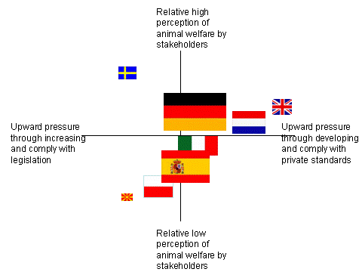

This simplified representation strongly suggests that concerns about and action to improve AW increases with economic development – the richer countries tend to experience greater pressure to develop and comply with private standards and also tend to experience greater perceptions of animal welfare by stakeholders.

D.3.2: found that the most preferred policy objective for AW (scored highest in the Delphi Survey) was “Improving public awareness of farm animal welfare issues”. The proposed short list of policy instruments to achieve this preferred policy objective were:
- “Education-based initiatives for the general public”,
- “Education/training-based initiatives for chain actors”,
- “Labelling schemes”
- “Promoting relevant research and development”.

The relative ranking of Policy Objectives and Policy Instruments over the whole participant countries is shown in Table D3.4 xx: (with columns (objectives) re-ordered in the priorities identified in WP3, and with the high scores (≥ 4) highlighted in red, and the ‘near misses’ (≥ 3.9) in yellow). The task for WP4, and especially for 4.3, is to identify, so far as possible, the consequences of these generally preferred improvements in animal welfare policies and industry strategies (policies and instruments) for the competitiveness of European agriculture. This is a tall order, and is plagued by both imprecision of the specific instruments and their effects, and about general uncertainty of the consequences.
Table D3.4 xx: Objectives and Instrument Priorities.
POLICY OBJECTIVES/ POLICY INSTRUMENTS | 1. Public awareness of farm animal welfare | 2=: On-farm standards | 2=: Education & information to chain | 4. Off-farm standards | 5. Education & inform to consumers | 6. Consumer trust & confidence | 7. New markets & existing markets
Government  regulations | 3.07 | 3.71 | 3.46 | 3.93 | 3.02 | 3.42 | 3.23
Private regulatory schemes | 3.1 | 3.66 | 3.49 | 3.66 | 3.08 | 3.49 | 3.72
Incentive schemes (farmer payments ) | 2.79 | 3.93 | 3.63 | 3.68 | 2.71 | 3.09 | 3.64
Labelling (+ 3rd party inspection) | 3.98 | 3.84 | 3.51 | 3.73 | 3.88 | 3.98 | 4.07
Industry schemes (no 3rd party inspection) | 2.97 | 2.97 | 2.96 | 2.92 | 3.26 | 3.01 | 3.05
Education for general public | 4.41 | 3.65 | 3.53 | 3.57 | 4.38 | 4.04 | 3.96
Education/ training for chain actors | 3.59 | 4.1 | 4.31 | 4.05 | 3.34 | 3.55 | 3.63
Increased capacity building for services | 3.41 | 3.77 | 3.95 | 3.69 | 3.33 | 3.34 | 3.5
Promoting R&D | 3.7 | 4.09 | 3.88 | 4.04 | 3.88 | 3.72 | 3.81
* These judgments are derived from a Delphi Survey of 197 stakeholder representatives over the 8 participant countries (of 458 approached).
A Belief Network Approach.
Uncertainty arises in many situations. Experts may be uncertain about their own knowledge; there may be uncertainty inherent in the system being considered; uncertainty about the accuracy and availability of information; about the precise nature and form of the relationships between the variables of interest; and even about the precise nature and form of the variables themselves. Belief networks (BNs) provide consistent semantics for representing uncertainty and an intuitive graphical representation of the interactions between various causes and effects. As a consequence, they are proving to be a very effective method of modelling uncertain situations that depend, or at least are assumed to depend, on cause and effect. Belief networks are especially useful when the information about the past and/or the current situation is vague, incomplete, conflicting, and uncertain.
BNs are compact networks of probabilities that capture the probabilistic relationship between variables, including historical information about their relationships. They are very effective for modeling situations where some information is already known and incoming data is uncertain or partially unavailable (unlike rule-based or “expert” systems or decision trees, where uncertain or unavailable data results in ineffective or inaccurate reasoning). BBNs (also known as Bayesian networks, Bayes networks and causal probabilistic networks), provide a method to represent relationships between propositions or variables, even if the relationships involve uncertainty, unpredictability or imprecision. Because of all of these capabilities, Bayesian belief networks are being used increasingly in a wide variety of domains where organized and transparent reasoning is needed. For instance, the BBSRC’s Institute for Food Research is using this approach for the analysis of food safety issues.
Bayesian belief networks are not dependent on knowing exact historical information or current evidence. Given that humans are excellent at vague linguistic representations of knowledge (for example, “it will probably rain tomorrow”), and less adept and providing specific estimates, the ability to be effective despite vagaries in the input information is particularly advantageous. This robustness in the face of imperfect knowledge is one of the many reasons why Bayesian belief nets are increasingly used as an alternative to other formal representations or mathematical computational models. They may be learned automatically from data files, created by an expert, or developed by a combination of the two. They capture knowledge in a modular form that can be transported from one situation to another; in a form people can understand, and which allows a clear visualization of the relationships involved. By distinguishing between decision variables (things that can be controlled), and utility variables (things we want to optimize) in the belief network, a decision network (also known as an influence diagram) can be developed.
Although Bayesian probability has been well-known for years, the Bayesian propagation computations necessary, even for small belief networks, are very complex. It is only recently that efficient algorithms have been developed to compute propagation in networks with a reasonable number of variables, hence they are a relatively new applied analytical tool.
An outline BBN for European Animal Welfare.
Based on the lessons learned from WP3, it is possible to outline a BBN for the EU’s Animal Welfare system as shown below (Figure 8). Here, we have outlined an ‘alpha’ version of a possible BBN representation of the priorities and apparent but implicit linkages between the objectives and instruments for improving AW identified in WP3. The ‘alpha’ version needs to be considered and amended by Stakeholders prior to eliciting their beliefs about the current states of the variables, and hence the implicit outcomes. Once the general structure (variable (‘node’) definition and directional relationships (‘edges’) between then) is established, the ‘beta’ model can be populated with expert (stakeholder) judgements about the current state of the system as represented by the network. This elicitation can be done electronically with a relatively simple Delphi-like survey of stakeholders for their beliefs about the current states of each of the variables (nodes) identified in Figure 1. The system then amalgamates the stakeholders’ beliefs forming a system which is then capable of manipulation and exploration.
This representation contains the key variables identified in WP3, and includes a preliminary judgement about the directional causation between them. The representation has been kept deliberately simple and parsimonious, as a basis for discussion and agreement amongst the core group of stakeholders (Amsterdam, March, 2011).
At the centre of the belief network is LABELING, the effectiveness of which depends on the underlying STANDARDS, which may be weak or strong. Although this particular instrument (Labelling) does not score especially highly in the Delphi survey (3.2), it does seem to be the fulcrum through which the other preferred instruments (standards) are likely to have their effects on the priority objectives. The strength of the standards depends on 3 key factors, as identified here: the Chain Education, R&D, and TRUST in PUBLIC ADMIN, since the administration and implementation of standards clearly affects the strength of standard application. Trust in Public Admin, in turn, depends on Public Education. The effectiveness of Labeling also depends on TRUST in MARKETS, which also depends on the extent of Public Education, since the effectiveness of labels requires people to trust their provenance. Given well-informed and well implemented labels, backed up with strong standards, EU ANIMAL WELFARE then depends also on PUBLIC AWARENESS, conditioned by the SOCIO-ECONOMIC CULTURE, where, a priori, richer countries might be expected to be more aware of animal welfare as an issue, and be willing to do something about it, than poorer countries.
Figure 8: Econ Welfare Belief Network (‘alpha’ version).
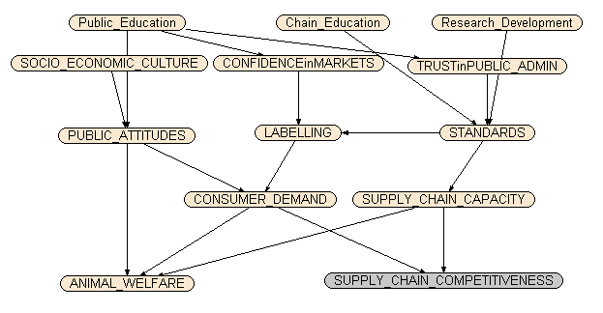
Added to the variables from WP3 are the Willingness to Pay (WTP) for AW (CONSUMER DEMAND) and the Willingness to Comply (SUPPLY CHAIN CAPACITY) variables. WTP is a demand-side measure of the extent to which consumers are willing to support improved animal welfare though paying a premium (as necessary) for high standard, labelled, products. Supply Chain Capacity is a supply-side measure of the extent to which the supply chain, including farmers, has both the capacity and the willingness to provide better AW, and is expected to be greater the lower the net costs (greater the net benefit) of ensuring improved AW. These two variables combine to determine the effects of animal welfare standards and labels on the competitiveness of the EU animal production and supply chain (SUPPLY CHAIN COMPETITIVENESS).
Step 2 in the implementation of this approach requires the major stakeholders to ‘sign-off’ on the general structure – generating the ‘beta’ model. Stage 3 then involves surveying all the stakeholders (i.e. those responding to the Delphi) for their judgments of the state of the current system to generate a ‘gamma’ model which will operational in the sense that it can be used to analyse and explore the consequences of changes. At least in principle, this systematic representation can be operationalised to explore the possibility and extent of a major trade-off between improved EU animal welfare the competitiveness of the EU animal chain. This approach also provides a mechanism through which the effects of changes in the state of these key variables can be explored – as an aid to further discussions and negotiations about future strategy and policy.
BBN Data Collection & Network Calibration
Data collection for the Econ Welfare Bayesian Belief Network follows the classical (theoretical) stages outlined above. Based mainly on findings provided by Workpackage 3, a BBN ‘alpha’ model was created by researchers at Newcastle University using Netica (Norsys) software. This model was then presented to some 20 stakeholders (NGOs, industry, academics and farmers representatives) at the Amsterdam workshop (in March 2011). During this interactive workshop, stakeholders were asked to consider and amend, according to their animal welfare expertise and beliefs, the general structure of the model (the definition of nodes) and the direction of causality (edges) between the nodes. The alpha model was subsequently presented to the European Farm Animal Welfare Council meeting in Bergen in March, 2011 and the members were also asked to contribute to the improvement of this model. In addition, researchers involved in the Econ Welfare project have also contributed to the specification of the BBN representation.
After all comments were incorporated, a ‘beta’ model was circulated to all partners and sent to those previously responding to the Delphi survey (WP3). Experts were asked to provide as many 'cases' (collections of node ratings) as possible, and for each case to 'score' according to their judgement and beliefs the state of the current animal welfare system in their country, region or sector. Each node included four ‘states’ with a score between 1 and 4 (e.g. for labelling: very effective = ‘1’, effective = ‘2’, ineffective = ‘3’ and very ineffective = ‘4’). 82 cases across the eight countries were received by the end of June 2011.
However, even this highly simplistic picture of the Animal Welfare system still suffers from considerable complexity. As specified in the ‘beta’ version of the network, there are more than 800 conditional probabilities. To properly ‘train’ this network with expert judgements of the scores for each node would require upwards of 8,000 cases (separate judgements of present conditions). Further simplification is both possible and necessary for our purposes. In this case, condensing the responses in each node from four possibilities (e.g: very high; high; low; very low) to two (‘high’ or ‘low’) substantially reduces the total conditional probability set to 84, which is more consistent with our data. However, we have been unable within the resources of this project to obtain enough separate judgements for a substantially reliable representation, so what follows can only be considered as an illustration of the approach.
Our ‘trained’ version of the Belief Network is shown in Figure 9. Each variable (node) box shows the proportion of our total sample of cases (82) answering with each score. In each case, apart from the bottom left hand node (ANIMAL WELFARE), the 4-scale scores have been contracted to 2-scale by aggregated the very good/good to the ‘good’ score and the poor/very poor scores to the ‘poor’ score. However, our respondents provided judgements about the present conditions of animal welfare in the EU which were highly skewed towards the good/very good end of the spectrum (a notable result in itself), as shown in Figure 10, with only 7% of our responses recording present animal welfare as poor or very poor. As a consequence, the trained network showed very little response of animal welfare to chainges in any of the presumed ‘drivers’ in this case. However, re-calibrating the network to consider only the very good response (17.3%) in the animal welfare node as ‘good’, and treating all other responses (82.7%) as ‘poor’ allows some indicative response patterns to be indentified.
Figure 9: Econ Welfare Belief Network (‘trained’/calibrated version).

Figure 10: Beliefs about Current Animal Welfare and Supply Chain Competitiveness in the EU.
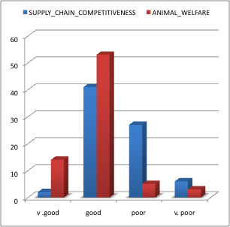The bi-value distribution of our respondents judgements on the current state of the variables driving animal welfare and supply chain competitiveness are shown in Figure 9, with slightly more (57%) considering that the supply chain is currently reasonably strong compared with 43% who consider it weak (or very weak). It is also notable that our respondents tend to judge labelling and public education weak rather than strong, 67.4% and 69.2% respectively, while they are more satisfied with the current states of chain education, R&D, trust in public administration, standards and public attitudes (63%, 61.5%, 70%, 66.2% and 65.4% respectively considering these to be good/high rather than poor/low).
Belief Implications for Improving Animal Welfare
Given these beliefs about the current state of the ‘animal welfare system’ in Europe, it is possible to explore the consequences of improvements in the major drivers for both animal welfare and chain competitiveness. Figure 11 shows the consequences of improving the state of public education from 31% good to 100% good.
Figure 11: Improving Public Education.
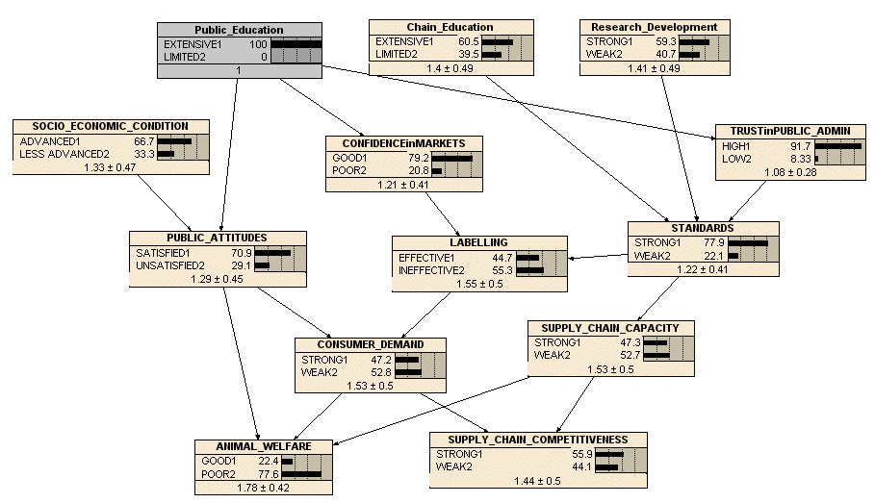
According to the beliefs of our respondents, this improvement would increase animal welfare from 17.3% good to 22.4% good (Figure 11 cf. Figure 9), and very slightly (insignificantly) weaken competitiveness from 57% to 56%. This consequence follows from the effects of public education on public attitudes, confidence in markets and trust in public administration, which in turn improve consumer demand, standards and labelling and supply chain capacity.
Similarly, Figure 12 shows the implications of improving market demand (independently of other variables) from 45.4% strong to 100% strong. If this could be achieved, the consequence would be both an improvement in animal welfare (17.3% to 24.4% good) and in supply chain competitiveness (from 56.9% to 58.6% strong). The implications, according to this belief network, are that the determinants of market demand, especially the effectiveness of labelling and the strength of standards, would also need to improve, from 32.6% to 37.9% effective and from 66.2% to 67.9% strong respectively.
Figure 13 shows the consequences of improving standards from 66% to 100% strong, other things being equal. Again, this would improve animal welfare, from 17.3% to 20.2% good, and marginally improve supply chain competitiveness from 56.9% to 57.6% strong. These consequences follow from improvements in labelling effectiveness (from 32.6% to 42.5%) and thus in consumer demand (from 45.4% strong to 46.6% strong).
The implications of this pattern of beliefs (noting the caveat that we do not have sufficient beliefs to calibrate (train) this network robustly) are that improving animal welfare does not need to compromise supply chain competitiveness, despite the simple economic analysis, which apparently suggests that the twin objectives will generally be conflicting. However, as Figure 14 illustrates, the belief that the objectives are in conflict is also apparent in this network.
Figure 12: Improving Consumer Demand
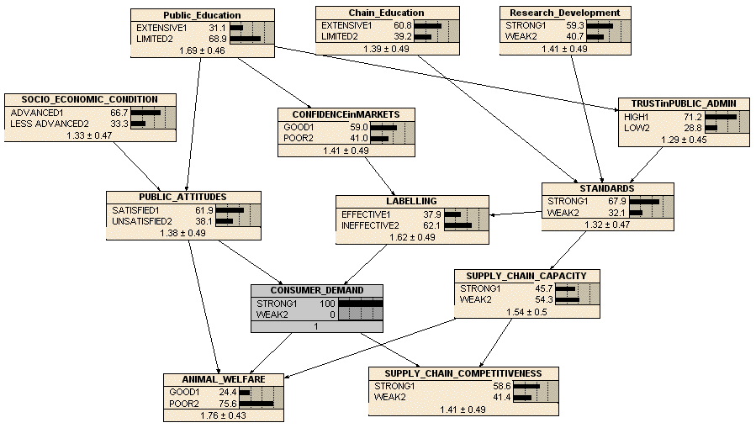
Figure 13: Improving strength of standards
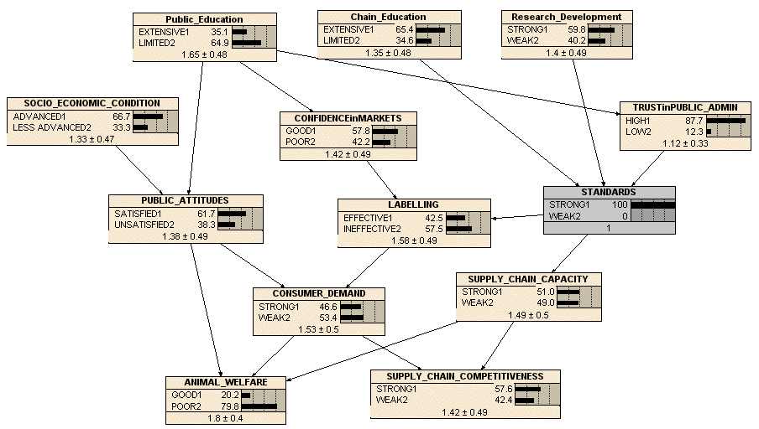
Figure 14: Improving Supply Chain Capacity
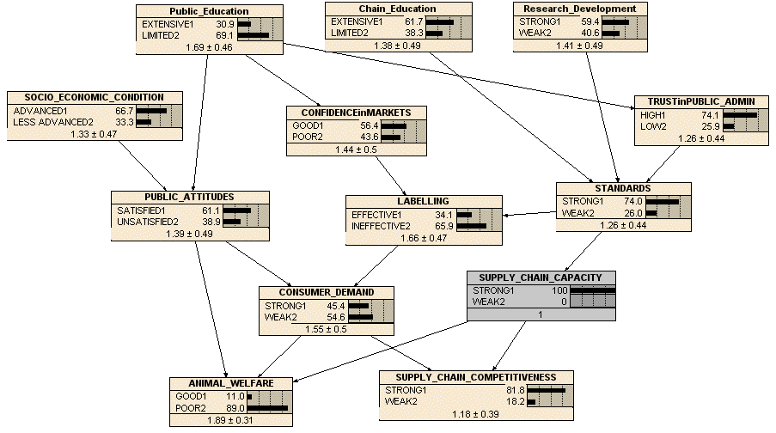
Simply improving supply chain capacity according to this belief network reduces animal welfare from 17.3% to 11% good, while improving competitiveness from 56.9% 5o 81.8%. This belief pattern apparently reflects the ‘vicious circle’ of animal welfare (D4.2) – that increased competition tends to harm animals as businesses strive to make money – rather than the ‘virtuous circle’ (D4.2) where more intelligent businesses pay attention to both actual and potential consumer and citizen demands, as well as more able producers learning that improved animal welfare can also be more productive, or at least no less productive.
Summary and Conclusions.
The simple economic analysis of the consequences of improving animal welfare on international trade and supply chain competitiveness implies that the twin objectives are likely to be in conflict. Improving animal welfare, in otherwise competitive markets, are supposed in this analysis to increase the costs of producing animal products, which (other things being equal) will reduce competitiveness of the producers relative to their international competitors (and, as far as consumers are concerned) relative to other goods and services. The implications of this simple story have been illustrated here both with a stylised diagrammatic model and through application of the farm-level cost/benefit analysis of D4.1 using an EU-wide model of the agricultural sector (Agmemod).
However, as the analysis in D4.2 showed, there are both supply conditions and demand side circumstances which may well resolve the apparent conflict between animal welfare and chain competitiveness. On the supply side, it is apparent (e.g the cost/benefit results in D4.1 for dairy cows) that there are animal welfare improvements that can be made without compromising competitiveness at all – in fact, in this case, the opposite. Not everyone is doing as well as they could (industry best practice), so supply chain information, education and training may well be able to improve both animal welfare and competitiveness. In addition, better understanding of both animal welfare and animal productivity (through R&D) can be expected to lead to improvements in both objectives. Our belief network, however, does not demonstrate these linkages to any significant extent.
On the demand side, it is clear that at least some people are both interested in and willing to support improved animal welfare, both by supporting animal welfare advocacy groups and by seeking out animal welfare friendly products and supply chains. The proportion of the total population who are more kindly disposed towards farmed animal welfare is also likely to increase both with income and with public education. Provision of more reliable labels (or incorporation of improved animal welfare standards within more general brands and trademarks), backed with verifiable standards, will re-inforce and extend the ‘market’ for improved animal welfare.
It is also clear that conditions and circumstances change over time – societies develop and evolve. These complex dynamics have not been examined in this deliverable, and indeed there are no substantive analytical frameworks that are capable of dealing with this complexity. However, it is apparent from the history of animal welfare in Europe that societies do become more aware of and concerned about animal welfare over time (as they become better off, more secure, better educated and informed). As they do so, producers, suppliers and retailers become more aware of and responsive to both citizen and consumer demands for better treatment of animals. The processes of governed market competition (D4.2) become more focused on both resolving the simple conflict between animal welfare and commercial survival (competitiveness) and harmonising private initiatives with market regulation and public support.
There is no simple recipe or single initiative or action which stands out as being fundamental to the improvement of animal welfare and the sustainability of European farm and supply chain businesses. The system is complex, but essentially systematic. Both the analytical logic (D4.2 and here) and the evidence from our stakeholders and patterns of existing initiatives and standards (WPs 1, 2 and 3) point in the same directions: better education, more reliable standards and labels (brands and trademarks), more public/private cooperation, and more R&D into both animal welfare and social (consumer/citizen) attitudes to and behaviour towards animal welfare. Improved animal welfare can thus be considered complementary rather than antagonistic to improved competitiveness and sustainability.
References
AGMEMOD Partnership (2005). Impact analysis of the CAP reform on main agricultural commodities. Final Report. European Commission Directorate General JRC – IPTS.
Conforti P. (2001). The Common Agricultural Policy in main Partial Equilibrium models. Osservatorio sulle Politiche Agricole dell'UE, INEA, Working Paper No. 8.
Chantreuil F., Hanrahan K. (2007). AGMEMOD EU Argicultural Market Outlook. Drustvo Agrarnih Ekonomistov Slovenije, DAES.
Chantreuil F., Donnellan T., van Leeuwen M., Salamon P., Tabeau A., Bartova L. (2008). EU dairy quota reform – AGMEMOD scenario analysis. XIIth Congress of the European Association of Agricultural Economists, Ghent, Belgium.
Chantreuil F., Tabeau A., Van Leeuwen M. (2008). Estimation of impact of EU agricultural policies on the world market prices. Modeling of Agricultural and Rural Development Policies. Sevilla, 107th EAAE Seminar "Modelling of Agricultural and Rural Development Policies". Sevilla, Spain.
Donnellan T., Hanrahan K., McQuinn K., Riordan B. (2002). Policy analysis with AG-MEMOD Model: Dealing with diversity in the EU Agri-Food Sector. RERC, Paper prepared for presentation at the EAAE Congres 2002.
Esposti R., Camaioni B. (2007). Technical Report on the Modeling Structure, AGMEMOD WP2 D2, Project no. SSPE-CT-2005-021543.
Marcot, B.G., Steventon, J.D., Sutherland, D.G. and McCann, R.K, 2006, “Guidelines for developing and updating Bayesian Belief Networks applied to ecological modeling and conservation”, Canadian Journal of Forest Research, 36, 3063 – 3074.
Salamon, P., 2008, “The Agmemod Tool, Version 4, Stylised Model Equations”, Braunschweig, 2008
Van den Bossche, P., Schrijver, N. and Faber, G. (2007) Unilateral Measures addressing Non-Trade Concerns. A study on WTO Consistency, Relevance of other International Agreements, Economic Effectiveness and Impact on Developing Countries of Measures concerning Non-Product-Related Processes and Production Methods. The Hague: the Ministry of Foreign Affairs of The Netherlands

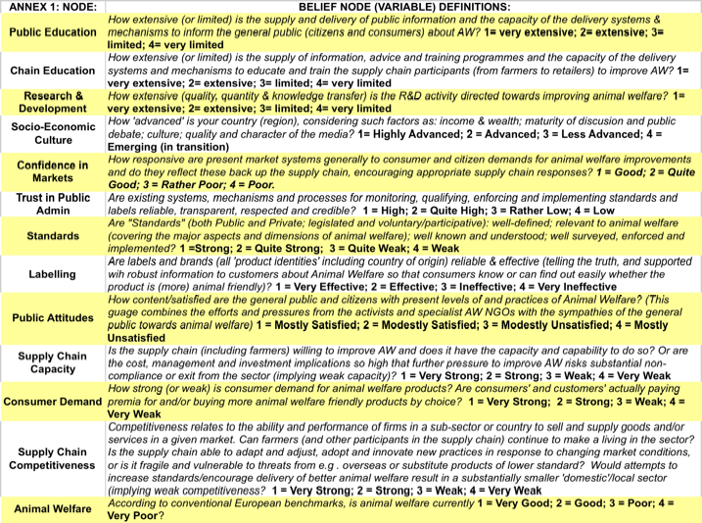

Colophon

This report is an official deliverable of the EconWelfare project.

EconWelfare is a European research project aiming to provide suggestions for national and European policy makers to further improve farm animal welfare. In collaboration with stakeholder groups it collates and investigates the options and their impacts on the livestock production chain, the animal and European society.

The research leading to these results has received funding from the European Community’s Seventh Framework Programme under grant agreement no. KBBE-1-213095

Project Office EconWelfare
ASG Veehouderij BV
Edelhertweg 15
P.O Box 65, 8200 AB Lelystad
The Netherlands
Phone +31 320 293503
Fax +31 320 238050
e-mail anke.delorm@wur.nl
The text of this report represents the authors' views and does not necessarily represent a position of the European Commission who will not be liable for the use made of such information.

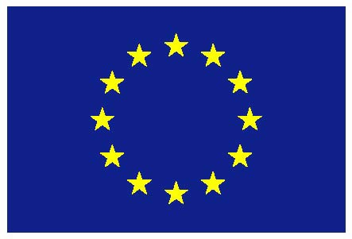

The “other things being equal” caveat is critically important. This compartative-static analysis can only be conducted by making analytical assumptions. In this case, the slopes of the supply and demand curves ONLY reflect the consequences of changes in the market price of the product – holding everything else that might affect either supply or demand constant (unchanged). To consider the effects of changes in these other important factors which determine supplies and demands, the curves have to be shifted.
It is often true that an individual firm can exploit economies of scale in expanding output, and hence be able to produce more at a lower average cost per unit. However, competitive markets will generally ensure that most available economies of scale are more or less fully exploited. Increasing demand for the industry’s products then requires more firms (or an expansion of existing firms), which will generally be associated with increased costs at the industry level.
The market in the RoW (RoW’s supply and demand curves, and levels of production and consumption) is not shown in Figure 1, but is implicit in the construction of the RoWXD curve – as the (missing) third panel in the right of the diagram.
This presumption does not deny that in practice there are improvements which can be made to at least some producers’ production practices to improve animal welfare without increasing production costs. In general, as argued in D4.2, competitive markets will act to encourage the adoption of cost reducing/animal welfare improving changes in production practice.
Elasticities measure the proportionate change in demand (supply) with a change in price (as the % change in quantity demanded (supplied) per unit % change in price. So, an elasticity of 1 says that a 10% increase in price will increase supply quantity by 10%, while -1.5 says that an increase in price of 10% will lead to a decrease in demand quantity by 15%.
Agmemod is an acronym of the name of the project: Agriculture Member States Modeling, constructed within the 5th and 6th EU Framework Project in cooperation with several European research institutes (Agmemod, 2005). This research was supported by EU FP6 research funding, contract SSPE-CT-2005-021543, by contributions from the partners’ institutes throughout the EU and through associated projects for the Institute for Prospective and Technological Studies (IPTS). The authors acknowledge the work of the AGMEMOD Partners in the development of the model used for this study. http://www.agmemod.eu/."
According to the analysis in D4.2, we would expect these improvements to be adopted over time, even if nothing else changes, since they would apparently improve productivity. This result seems to imply that the dairy sector is somewhat less competitive at the farm level than the other sectors – since otherwise we would expect that these improvements would already be widely adopted. It may be that the extent and nature of CAP support and protection for the dairy sector has limited the competitive pressures.
Where exports are typically chosen to close the model.
Since May 2005, the World Assembly of OIE Delegates (representing the 174 Member Countries and Territories) has adopted six animal welfare standards in the OIE Terrestrial Code. These standards cover: transport of animals by land; transport of animals by sea; transport of animals by air; slaughter of animals for human consumption; killing of animals for disease control purposes; control of stray dog populations. “These standards are regularly updated to take account of latest scientific findings” (OIE, web site).
Biotechonology and Biological Sciences Research Council, UK
“Netica performs standard belief updating which solves the network by finding the marginal posterior probability for each node. … Netica assumes that conditional probabilities are independent and that prior probabilities are … continuous and bounded between 0 and1.” (Marcot et al., 2001:30).
Annex 1 presents the general structure of the model with the definitions of each of the nodes and states as provided to experts.

