IV INTERNATIONAL SEMINAR

"SILICON CARBIDE AND RELATED MATERIALS"

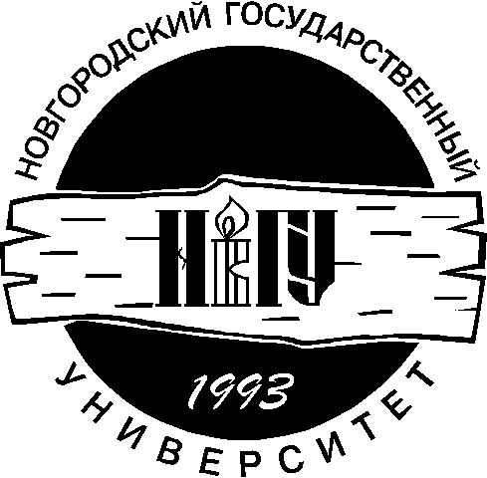

ISSCRM - 2002

30 - 31 MAY

P R O G R A M
SHORT FORM

NOVGOROD THE GREAT

30 MAY

9.00 - 10.00 REGISTRATION OF PARTICIPANTS

10.00 - 14.00 SESSION 1 "CROWS OF CRYSTALS AND EPYTAXIAL FILMS"
ORAL CONTRIBUTIONS

1. GROWS OF LARGE DIAMETER SiC INGOTS
Avrov D.D., Dovozhkin S.I., Lebedev A.O., Maximov A.Yu., Taivov Yu.M.

2. Defect formation in SiC crystals grown by the Modified Lely method
M.M. Anikin ¹, M. Pons ², E. Pernot ¹, R. Madar ¹

3. PURIFICATION OF GRAPHITE MATERIALS AND SILICON CARBIDE POWDERN.
N. Kuznetsov, A.A. Jokhov

4. POROUS WIDE BAND-GAP SEMICONDUCTORS: PROSPECTIVE APPLICATIONS.
M. Mynbaeva

5. FEATURES OF SUBLIMATION GROWTH ON POROUS SIC SUBSTRATES.
N.S.Savkina, V.B.Shuman, B.B.Ratnikov,A.Yu.Rogachev, A.S.Tregubova, L.M.Sorokin, A.A.Volkova.
6. EFFECT OF GROWTH PROCESS DURATION ON THE PROPERTIES OF GaN GROWN BY SUBLIMATION METHOD A.A.Wolfson, E.N.Mokhov

7. OPTIMAL CONTROL IN SiC BULK CRYSTAL GROWTH BY SUBLIMATION
A.V. Kulik ¹⁾, S.E. Demina ¹⁾, M.V. Bogdanov ¹⁾, M.S. Ramm ²⁾, A.I. Zhmakin ²⁾, Yu.N. Makarov ³⁾

14.00 DINNER

15.00 - 17.00 SESSION 2 " PHYSICAL PROPERTIES OF WIDE BAND - GAP MATERIALS"

ORAL CONTRIBUTIONS

1. ELECTRICAL STUDY OF THE NEUTRON IRRADIATED 4H-SiC CVD EPITAXIAL LAYERS.
E. Kalinina, G. Kholujanov, D. Davydov, A. Strel'chuk, Ioffe Institute, St. Petersburg,

2. FIELD EMISSION MICROSCOPY STUDY OF O₂ ON MONOCRYSTAL 6H-SiC SURFACE V.G.Ivanov I.P. Ushakov

3. ON THE ORIGIN OF THE SHOTTKY BARRIER HEIGHT DEPENDENCE ON SILICON CARBIDE POLYTYPE IN METAL - SiC CONTACT
S.Yu. Davydov, A.A.Lebedev, O.V.Posrednik, Yu. M. Tairov

4. Formation of optically-active centers of Eu in bulk crystals
of GaN <Eu> under different methods of introduction of Eu
V.V.Krivolapchuk, M.M.Mezdrogina ,S.N.Rodin,A.P.Skvortzov, Ju.V.Zhilyaev.

17.00-18.00 POSTERS

18.00 BANQUET

31 MAY

10.00 - 13.00 SESSION 3 "DEVICES AND TECHNOLOGICAL PROCESSING"
ORAL CONTRIBUTIONS

- CURRENT STATUS IN SiC RESEARCH ACTIVITY
T.S.Sudarshan, I.I. Khlebnikov
- THE STATE OF THE ART OF R&D ON SiC IN JAPAN
T. Nakata
3. SILICON CARBIDE RESEARCH ACTIVITY IN SOUTH CAROLINA
T.S. Sudarrchan, I.I. Khlebnikov

4. Properties of modern bipolar SiC devices fabricated by Cree Inc.
M. E. Levinshtein*, P. A. Ivanov*, T. T. Mnatsakanov**, J. Palmour***, A. Agarwal*** and R. Singh***
- CHARACTERIZATIONS OF 3C-SiC EPILAYERS GROWN ON 6H-SiC SUBSTRATES BY VACUUM SUBLIMATION.
N.S. Savkina, A.A. Volkova, A.S. Tregubova, M.P. Scheglov, V.А. Solov′ev, , A.A. Lebedev.

13.00 DINNER-HOUR

14.00 - 17.00 SESSION 4 "DEVICES AND TECHNOLOGICAL PROCESSING"

ORAL CONTRIBUTIONS

6. SIC STATIC-INDUCTION TRANSISTOR
B.G. Konoplev, E.A. Ryndin

- THE 6H-SiC AVALANCHE PHOTOAMPLIFIERS
V.I. Sankin, P.P Shkrebiy, A.N. Kuznetsov, A.A. Lepneva, N.S. Savkina, and
A.A. Lebedev

- UV-photodetectors based on SiC Schottky diodes
A.V. Afanasjev, A.S. Gudovskikh, V. A. Il'in, A. A. Petrov

9. Silicon Carbide Thermomechanical actuator
A.V. Korlyakov, V.V. Luchinin, I.V. Nikitin.

16.00 - 17.00 POSTERS and DISCUSSION

